Safer sleeping this winter

Overview
The colder months can be difficult for families, especially with the added worry of heating bills during the current cost of living crisis. Those with young children and babies may be concerned about trying to keep their home warm, and the recommended room temperature of 16-20 degrees might be hard to achieve. Their first thought might be to wrap their baby up to keep them warm, but this can increase the chances of SIDS, also known as cot death.
This campaign aims to highlight the safe sleeping guidelines, promoting the best ways to keep babies warm this winter that isn’t necessarily just putting the heating on. There is the usual health angle of keeping babies safe if parents/guardians in their own cot or bed share, but a “new” cost of living concern regarding keeping babies warm in cold households.

Resources
- Social media messaging
- Poster
- Digital screens
- Video
- Copy for website
- Copy for internal comms

Key messages
- The safest place for a baby to sleep is in their own clear, flat, separate sleep space, such as a cot or Moses basket.
- Babies shouldn’t sleep indoors in any outdoors clothing, such as hats.
- Do not place your baby's cot next to a radiator or have a heat source, like a portable heater.
- Don’t be tempted to put your baby under adult bedding to keep them warm
- Don't use hot water bottles in any baby sleep space. Babies can’t regulate their temperature, and this can make them too warm
- Firmly tuck in sheets and blankets (no higher than the shoulders).
- If you are using a baby sleeping bag, don’t add extra blankets on top, add an extra layer of clothing or choose a higher tog sleeping bag if you feel the sleeping bag is not enough
- Choose the correct tog of sleeping bag for the different seasons.
- Make sure your baby won’t fall out of bed or get trapped between the mattress and the wall
- Do not bring other children into bed with you if you choose to bedshare with your baby

CTA
- Link to Council's cost of living support web page, where this information will live Let's manage tough times - Bury Council
- Lullaby Trust or NHS (Reduce the risk of sudden infant death syndrome (SIDS) - NHS (www.nhs.uk) for guidance
- Signpost to healthcare services if worried about baby: GP

Communication channels
- Community hubs, warm hubs, food banks
- Parent groups (via Essential Parent) and schools
- Staff newsletters
- Social media
- GP screens
- Bury Council website and Bury Directory

Social media assets
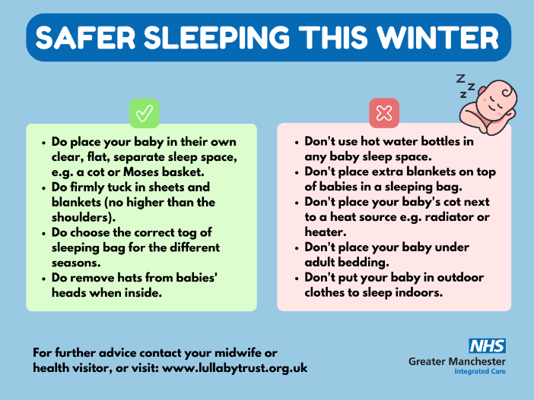
Asset 1 (supporting copy is below asset)

Facebook: The colder months can be difficult for families, especially with the added worry of heating bills during the current cost of living crisis. Your first thought might be to wrap your baby up to keep them warm, but this can increase the chances of SIDS, also known as cot death.

Follow the tips below to keep your baby safe whilst they sleep this winter. For further advice contact your midwife or health visitor, or visit: www.lullabytrust.org.uk

Twitter: The colder months can be difficult for families, especially with the added worry of heating bills. Your first thought might be to wrap your baby up to keep them warm, but this can increase the chances of cot death.

Follow the tips below to keep your baby safe whilst they sleep.

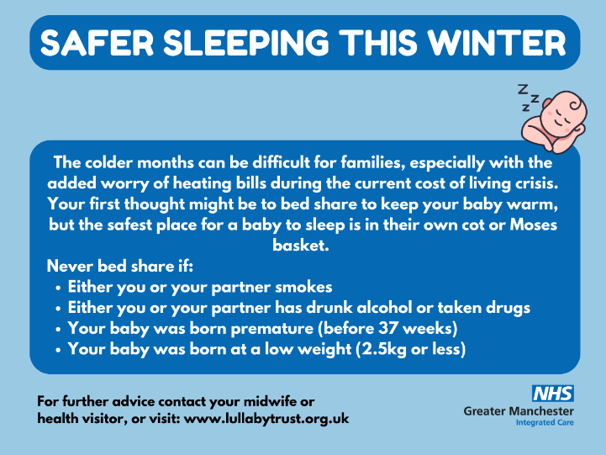
Asset 2 (supporting copy is below asset)

Facebook: The colder months can be difficult for families, especially with the added worry of heating bills during the current cost of living crisis. Your first thought might be to bed share to keep your baby warm at night, but this can increase the chances of SIDS, also known as cot death.

Follow the tips below to keep your baby safe whilst they sleep this winter. For further advice contact your midwife or health visitor, or visit: www.lullabytrust.org.uk

Twitter: The colder months can be difficult for families, especially with the added worry of heating bills. Your first thought might be to bed share to keep your baby warm, but this can increase the chances of cot death.
Follow the tips below to keep your baby safe whilst they sleep.

Web copy
The colder months can be difficult for families, especially with the added worry of heating bills during the current cost of living crisis. If you have young children and babies, you may be concerned about trying to keep your home warm, and the recommended room temperature of 16-20 degrees might be hard to achieve. Your first thought might be to bed share or wrap your baby up, but this can increase the chances of SIDS, also known as cot death. The safest place for a baby to sleep is in their own cot or Moses basket.
Follow the tips below to ensure your baby sleeps safely this winter.
- Place your baby in their own clear, flat, separate sleep space, e.g. a cot or Moses basket.
- Firmly tuck in sheets and blankets (no higher than the shoulders).
- Choose the correct tog of sleeping bag for the different seasons.
- Remove hats from babies' heads when inside.
- Don't use hot water bottles in any baby sleep space.
- Don't place extra blankets on top of babies in a sleeping bag.
- Don't place your baby's cot next to a heat source e.g. radiator or heater.
- Don't place your baby under adult bedding.
- Don't put your baby in outdoor clothes to sleep indoors.
Never bed share if:
- Either you or your partner smokes
- Either you or your partner has drunk alcohol or taken drugs
- Your baby was born premature (before 37 weeks)
- Your baby was born at a low weight (2.5kg or less)
For more support and advice to help you and your family this winter, visit: Let's manage tough times - Bury Council. For further information about safer sleeping, read NHS advice here: Reduce the risk of sudden infant death syndrome (SIDS) - NHS (www.nhs.uk), or visit The Lullaby Trust: The Lullaby Trust - Safer sleep for babies, Support for families

GP Screen image
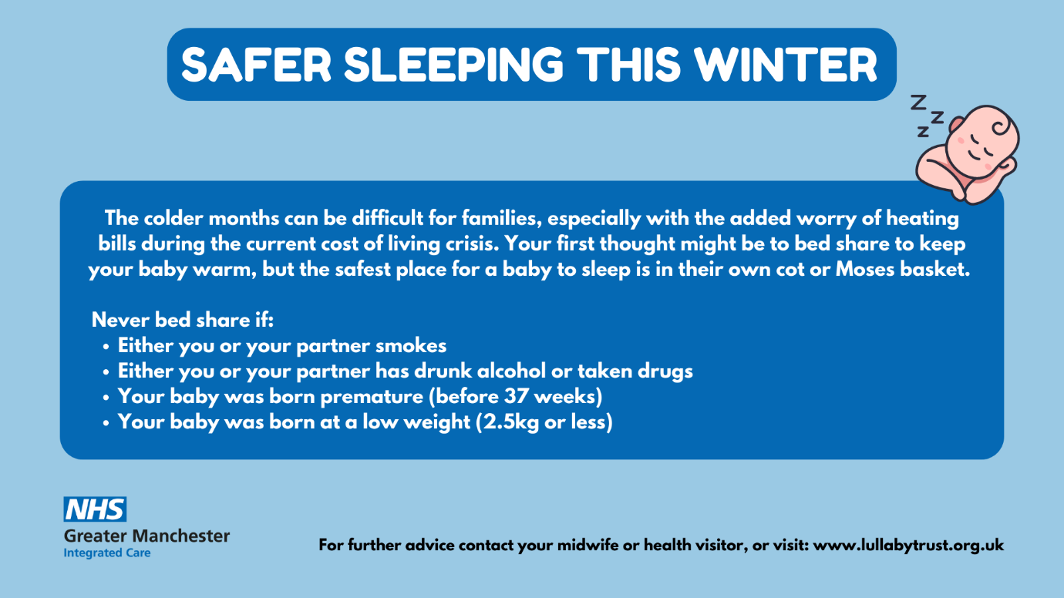
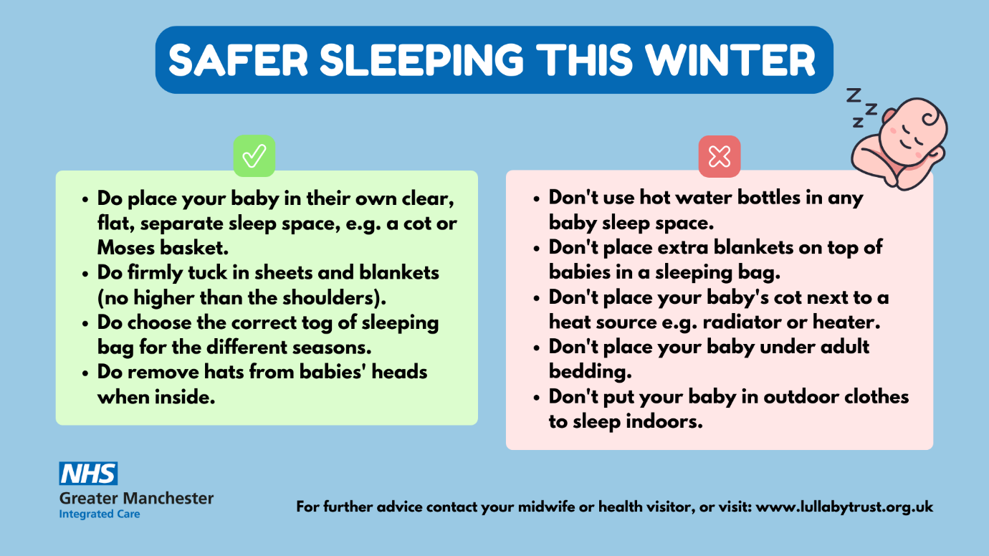

Poster
