

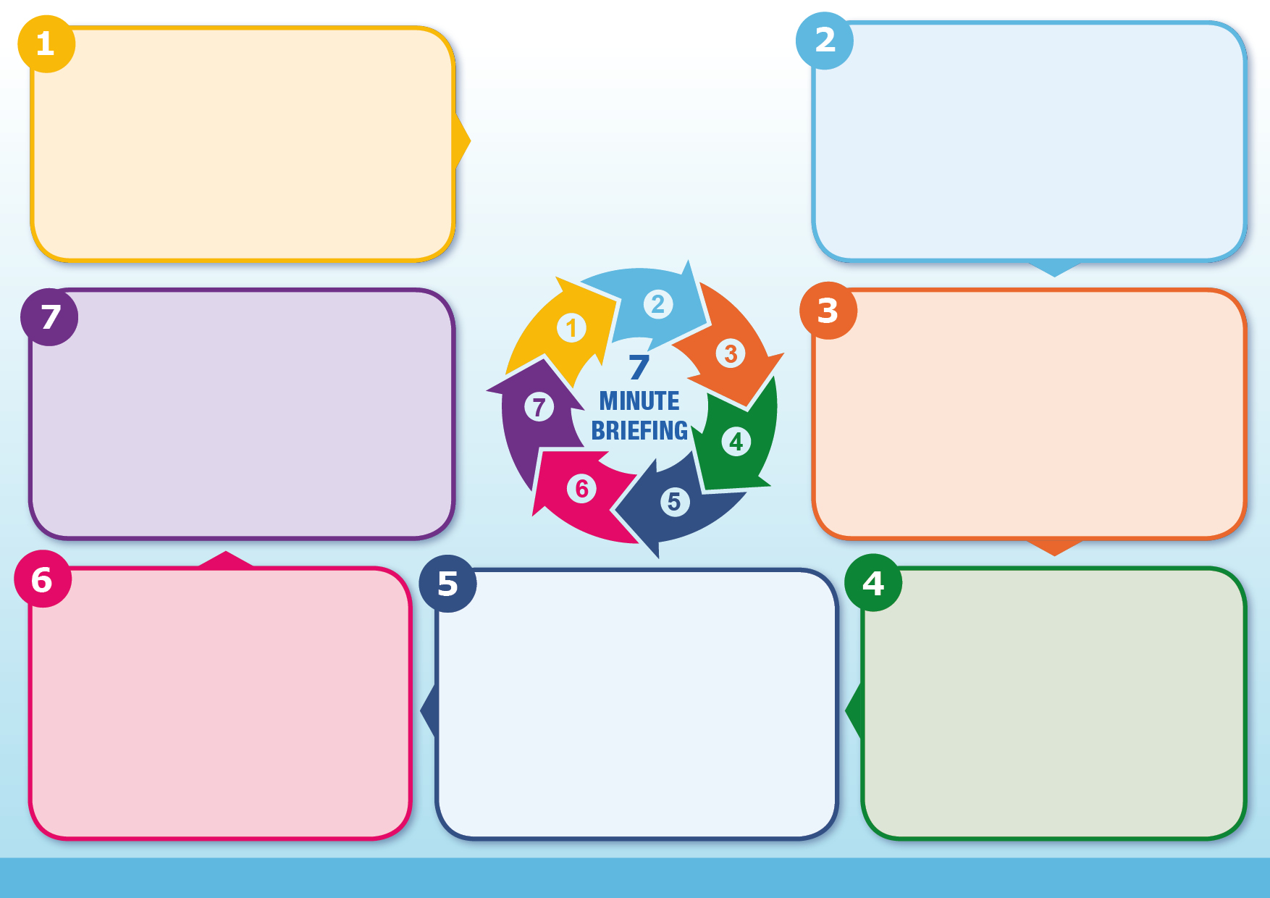
Key Messages
The safest place for a baby to sleep is back in a cot or Moses basket and in the same room as parents or carers for the first six months including and sleep period, day or night
• Sleeping with a baby on a sofa puts the baby at greatest risk.
• Infants should never share a bed with anyone who is a smoker, has consumed alcohol or has taken drugs (legal or illegal).
• The incidence of SIDS is higher in the following groups:
o parents in low socio-economic groups
o parents who abuse alcohol or drugs
o parents who smoke
o young mothers
Target parents during pregnancy with safe sleep messages. Also target grandparents, babysitters and others with caring responsibility for baby
Health professionals follow up regularly following birth and in early weeks of baby’s life
All professionals ensure consistent safe sleep messages are conveyed, and understood. Do not assume another professional has provided information
Be mindful of individuals absorbing, responding and acting upon messages according to their learning style
Ensure messages are consistent
Utilise every opportunity to provide safe sleep advice
Sleeping on sofa/ armchair
Baby overheating. Keep room temperature 16-21°C
Covering baby’s face or head while sleeping/ use of loose bedding
Cuddly toy in cot/ Moses basket
Sleeping in a car seat
Use of pillow, cushion or beanbag
Change in sleep circumstances e.g. routine
Bed sharing increases the chance of SIDS and is particularly dangerous/ should not occur if:
Either parent/ carer smokes (even if not smoking in the bedroom)
Either parent/ carer has drunk alcohol or taken drugs (including medications that may make you drowsy)
Parent/ carer are extremely tired
Baby was born prematurely (37 weeks or less)or was born at a
low weight (2.5kg or 5½ lbs or less)
Risk Factors
• SIDS claims the lives of 240 babies per year (5 per week)
• Around 85% of SIDS occur in first 6 months of baby’s life
• A baby placed on their front is 6 times more at risk than a baby placed on their back
• Sleeping on a sofa with a baby increases risk by 50 times
• In 2016 rate of SIDS was noted to be 3 times higher among mothers under 20 years old compared to other age groups
• Sharing a room with baby can halve the risk
• Babies with low birth weight at 3 times greater risk
• Boys more at risk than girls
• Over 1/3 of SIDS could be avoided if mothers didn’t smoke during pregnancy Source Lullaby Trust 2016
There is evidence from many long term studies of Sudden Infant Death Syndrome (SIDS) that some of the infant deaths associated with bed-sharing, co-sleeping and other factors associated with SIDS can be prevented.

There is no advice that guarantees the prevention of SIDS but parents should be informed that by following the advice in this briefing, it is possible to reduce the likelihood of SIDS occurring.
Placing baby on back to sleep
Keeping baby smoke free during pregnancy and after birth
Placing baby in separate cot or Moses basket to sleep
Ensure baby in same room as parent/ carer for first six months
Breastfeeding baby
Use of firm, flat, waterproof mattress, in good condition
• How can we in this team use this information to safeguard infants?
• Where do we see infants? Or their parents?
• Do we routinely ask about and view sleeping arrangements, and other carers?
• Do we routinely ask about alcohol, drugs and medication?
• Do we routinely give and discuss information about safer sleep?
• Do we check where the baby is sleeping and the temperature control of this area?
• Do we always document the advice given?
Why it matters
Background
Questions
Professional Role
Protective Factors
Safer Sleep

