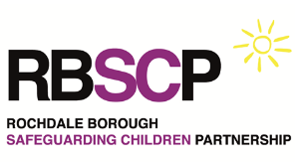
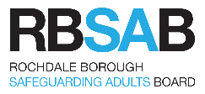
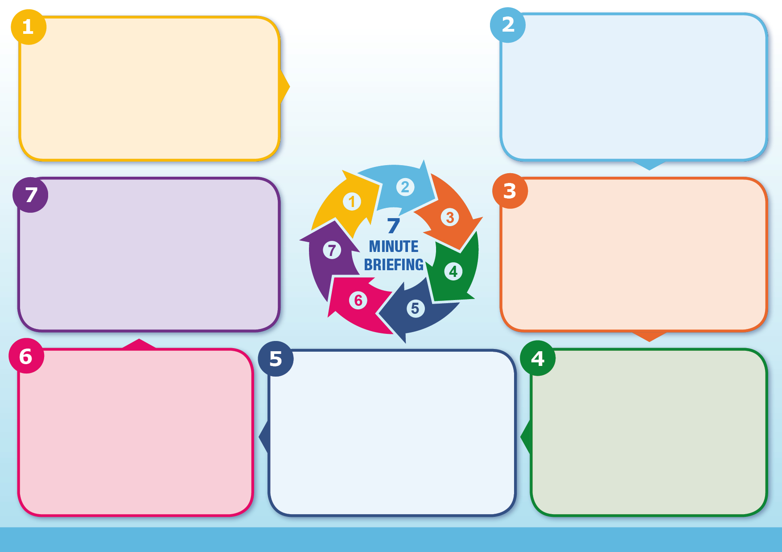
Disabled children are especially vulnerable to abuse for a number
of reasons. They may:
Have fewer outside contacts
Receive intimate care from a number of carers, which may increase the risk of exposure to abusive behaviour & make it more difficult to set & maintain physical boundaries
Be less likely to be consulted in matters affecting them
Other factors that increase vulnerability include:
Parents’/carers own needs may conflict with the needs of the disabled person
Professional sympathy for carers who are seen as ‘saints’
Abusers may target people with disabilities believing that they are less likely to be detected
Signs and indicators attributed to the disability & changes in behaviour not seen as an indicator that something is wrong
Making a referral for any safeguarding concern is the same as for any child. You need to make your referral through CEHASH
Always refer by phone without delay.
Then follow up with a Multi –Agency Referral Form within 24 hours
If in doubt, contact CEHASH who can advise 0300 303 0440
(Out of Hours 0300 303 8875)
Have an impaired capacity to recognise, resist or avoid abuse
Have communication difficulties that may make it difficult to tell others what is happening
Be inhibited about complaining for fear of losing services
Be less able to defend themselves & advocate for themselves
Be more vulnerable to bullying, intimidation and hate crime
Be less likely to be consulted in matters affecting them
Disabled children are at significantly greater risk of physical, sexual and emotional abuse and neglect than non-disabled children and yet they are typically under- represented in Child Protection statistics. Those at greatest risk of abuse are those with behaviour or conduct disorders. Other high-risk groups include children with learning difficulties/disabilities, speech and language difficulties, health-related conditions and deaf children. The presence of multiple disabilities appears to increase the risk of both abuse and neglect. Disabled children are more likely to be abused by someone in their family compared to non-disabled children. Bullying is also a feature in the lives of many disabled children. Disabled children may also disclose less
frequently and delay disclosure more often.
Why it matters
Disabled children have an equal right to protection from abuse as non-disabled children, a right enshrined in the UN Convention on the Rights of the Child.
Many disabled children encounter barriers in their daily lives that affect opportunities for accessing information and services, and engaging in social activities. Barriers can be physical, attitudinal or organisational and can leave disabled children feeling isolated and excluded and denied their rights.
Insufficient account can be taken of their views and experiences, and professionals and others may not always take the steps necessary to facilitate communication or attach a value to this. As a result, disabled children’s wellbeing can be compromised. These disempowering experiences can have an impact on
their confidence and self-esteem and have significant implications for safeguarding. For some minority ethnic disabled children these effects can be compounded.
Background
What to do
Are the wishes and views of the Child/Adult known?

What is daily life like for the Child/Adult?

Would I accept this for a non-disabled person?

What evidence supports the assessment?

Is there any evidence to suggest that the current assessment is wrong?
Questions
Information
Information continues
Information
Safeguarding Children with Disabilities

