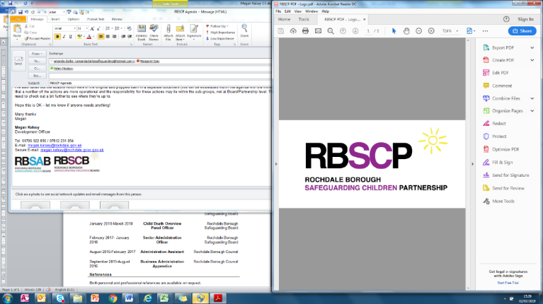

**Rochdale Borough Safeguarding Children**

**Partnership**

**Strategic Plan 2022**

**-**

**2024**

Rochdale Borough Safeguarding Children

Partnership**.**

**Who we are?**

The Safeguarding Children Partnership (SCP) is a multi-agency partnership which has statutory functions under the Children Act 1989, the Children Act 2004, the Children and Social Work Act 2017 and statutory guidance Working Together 2018.

The main focus of the SCP is to ensure that in the Rochdale Borough, safeguarding arrangements work effectively so that all children and young people are protected from abuse. .

**The structure of the RBSCP.**

The Executive Safeguarding Partners of the Rochdale Borough Safeguarding Board (RBSCP) have responsibility to coordinate safeguarding services, to act as the strategic leadership group in supporting and engaging others in the work of safeguarding children, promoting their welfare, obtaining assurance and implementing local and national learning.

The RBSCP Business Unit on behalf of the RBSCP Executive, our other partner agencies and through the work of our sub-groups produces a Safeguarding Children Strategic Business Plan which identifies the priorities of the RBSCP.

The RBSCP works closely with the Rochdale Borough Safeguarding Adults Board, the Rochdale Children and Young Peoples Partnership and Rochdale Safer Communities Partnership to ensure all priorities are aligned.

**Our Principles-** The principles of the RBSCP reflect our ‘business as usual safeguarding activities’. With our partners we commit to ensuring:

* Children are safeguarded and their welfare promoted
* Partner organisations and agencies collaborate, share and co-own the vision for how to achieve improved outcomes for vulnerable children;
* Partners provide safeguarding assurance, challenge appropriately and hold one another to account effectively.
* Information is shared effectively within and across organisations to ensure more accurate and timely decision making and action for children and families;
* There is focus on children and families– their voice is heard, and their lived experience seen and understood.

**How will we work?**

All work and actions undertaken will reflect and promote the ethos in Rochdale of relational working and trauma informed practice. Our responses will be strength based and keep the wellbeing and rights of children and young people at the centre of all that we do.

Our work will be continuously coordinated and evaluated to fulfil RBSCP statutory responsibilities.

**How our priority areas were developed**

Indeveloping the RBSCP priorities for 2022 to 2024 it was important to build on work undertaken over the last 2 years some of which has been impacted by the Covid-19 response. The priority areas were identified through a multi-agency process where all RBSCP partners provided information regarding safeguarding priorities within their own organisations and contributed to a wider discussion and agreement regarding priority areas for the RBSCP. The priorities have also been informed by local child safeguarding practice reviews, multi-agency audits, and local and national serious safeguardingissues.

**If you concerned that a child has or is suffering harm, neglect or abuse please call 0300 303 0440. If you feel a child is in immediate danger please contact the police on 999**



