Quality Assurance & Performance Framework

2026 - 2028

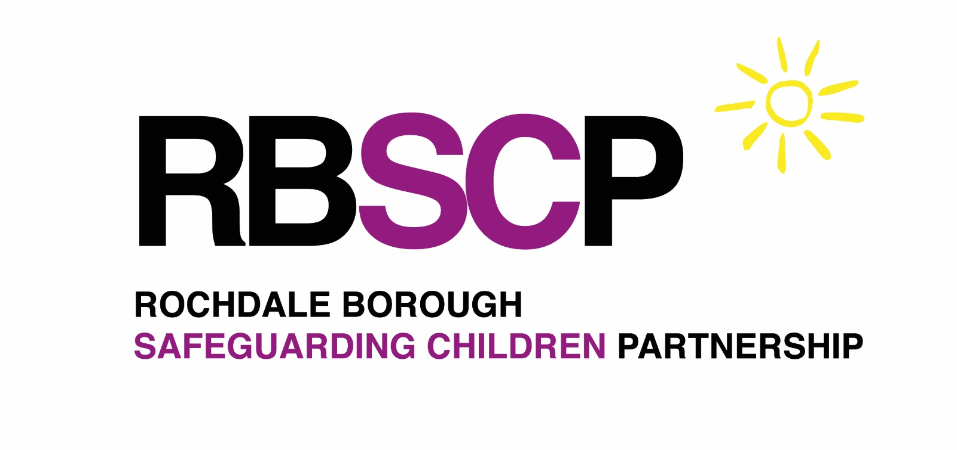

Table of Contents

Scope 2
Governance and Leadership 3
Our Quality Assurance and Performance Reporting Activity 4

Rochdale Borough Safeguarding Adults Board Quality Assurance Framework
Author | SPQA Subgroup | Status & version | Final Draft v4
Authorised by | Bev Paris | Authorised date
Circulation date | Feb 2026 | Review date | April 2028
Revised date | August 2026
Change control
August 2026 | Updated content to expand on daily lived experience

Scope

The Rochdale Borough Safeguarding Children’s Partnership (RBSCP) is committed to ensuring all children are effectively safeguarded through high quilt services. By working together and reviewing the quality of outcomes provided by services in the borough, we can be assured that children are provided with the services that help to keep them safe from harm, abuse and neglect. RBSCP will seek assurance that we improve services based upon the views and experiences of those receiving our services.

It is important to RBSCP that quality assurance and performance intelligence is shared widely to ensure learning reaches all parts of the safeguarding system, and the risk of activity repetition is minimised. Our strategic quality assurance framework will enable agencies to develop and share the effectiveness of safeguarding arrangements and services across Rochdale.

Who the framework is for

This Quality Assurance (QA) framework applies to all RBSCP partners with responsibilities for safeguarding children within Working Together to Safeguard Children statutory guidance.

Define Quality Assurance:

The RBSCP considers quality assurance (QA) to be the activity of testing the effectiveness of an action by the most appropriate method. This may be traditional case file auditing, but it may also be the use of surveys to gain qualitative information, or the use of data analysis to provide quantitative intelligence. The examples provided are not prescriptive but seek to highlight a range of QA techniques that may be undertaken to ensure intended outcomes can be evidenced.

The purpose of the QA Framework

Through shared standards, reflective practice, and robust oversight, this framework fosters a culture of learning and collaboration to protect children. The purpose of our QA activity should be to improve outcomes for children and their families living in Rochdale. It is therefore important that we take account and be influenced by current safeguarding priorities locally and nationally.

Governance and Leadership

The QA Framework is applicable to the full structure of RBSCP inclusive of Subgroups and partner organisations.

Implementation and delivery of this QA Framework will be overseen by the RBSCP SPQA Subgroup. Quarterly reporting on activity will be reported to the Sub-Group, and onward assurance reporting provided to the Safeguarding Children Executive.

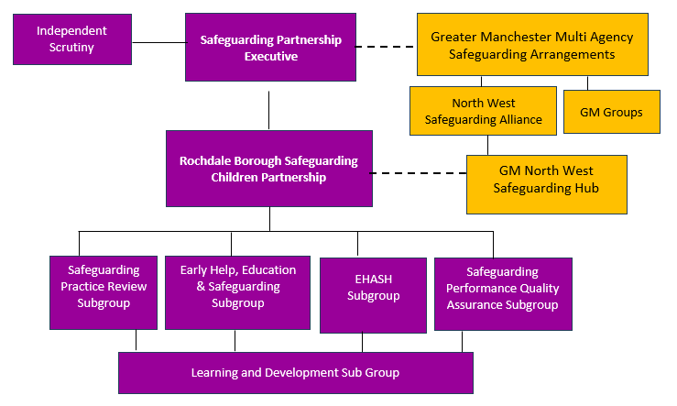
RBSCP has an expectation that all RBSCP subgroups will undertake QA activities, supported by the SPQA subgroup, to ensure our safeguarding activity is effective for children and can evidence compliance to process equates to positive outcomes and experiences for children.

RBSCP QA activity should be proportionate, and consistent in achieving defined strategic priorities.

The SPQA Subgroup will be responsible for maintaining a schedule of approved QA activity.

It is also important that single agency auditing which relates to RBSCP achieving its safeguarding aims is delivered to the SPQA Subgroup at the earliest opportunity to allow for multi-agency information sharing. The RBSAB Data Sharing agreement is available upon request to RBSB.admin@Rochdale.Gov.UK

The RBSCP acknowledges governance of single agency audit activity is the sole responsibility of that agency delivering information to RBSCP

The SPQA Subgroup Chair, supported by the Business Unit QA Officer will be responsible for the delivery of QA information and activity to RBSCP Executive. The lead of individual QA activities will be responsible for ensuring the learning is shared across the multi-agency system.

Our Quality Assurance and Performance Reporting Activity

The subject and method of our activity will vary depending upon the intended outcome. Our approach will be flexible, and we will take account of a range of evidence as part of QA activity. This will ensure a balance between qualitative and quantitative data is included in any analysis.

All RBSCP activity will consider a child’s daily lived experience including identity, culture, faith, and discrimination into account in design of methodology. This ensures the voice of children; their families and the local multi-agency workforce is heard by RBSCP.

It is important to RBSCP that support transparency and accountability. Reports will be designed to be accessible to all parts of the workforce and to the borough’s children and families, enabling them to understand the purpose of the activity, the evidence gathered, examples of good practice, and any recommendations made. This approach ensures and supports continuous improvement across the partnership. The learning from QA will be summarised in the RBSCP annual report.
Statutory Audits
RBSCP must carry out statutory audits under Section 11 of the Children Act 2004 and Sections 175/157 of the Education Act 2002. These laws place clear duties on organisations and education settings to ensure their functions are exercised with a view to safeguarding and promoting the welfare of children.
The SPQA Group will facilitate and provide reports for both statutory audits in line with agreed local processes. All RBSCP members must participate and contribute to statutory audits. These audits give safeguarding partners critical oversight of local safeguarding practice and help identify strengths, gaps, and areas for improvement across the system.
Performance data
As part of our Quality Assurance Framework, the systematic collection and analysis of safeguarding performance data is vital to ensuring the effectiveness of children’s safeguarding practices. This data provides measurable insights into referral patterns, types of abuse encountered, outcomes of safeguarding enquiries, and the experiences of those involved. By interrogating both quantitative and qualitative data we can identify trends, assess how RBSCP strategic priorities are being achieved, and ensure that safeguarding is both person-centred and outcome focused. Performance metrics also support accountability across partner agencies and enable continuous improvement by highlighting areas of good practice and those requiring development. As such, and in line with the RBSCP Data Sharing agreement, the Partnership requires members to share data for reporting when requested.
Policy and Process review
This area of quality assurance is the systematic evaluation of safeguarding policies and process to ensure they remain compliant with legislation, statutory requirements, aligned with best practice, and reflective of learning from audits, data, and stakeholder feedback. This includes assessing whether expectations are clear, current, effective, and consistently applied across the Partnership.
RBSCP Policies are held both centrally via Tri-X and locally via RBSCP website. Reviews will be led by the most appropriate RBSCP members as identified by the SPQA Subgroup. Identified members will revise policies or processes through planned communication, training, system updates, and ongoing monitoring to ensure changes are understood, embedded, and lead to measurable improvements in safeguarding practice and outcomes.
Confidentiality and Information Governance

All quality assurance and performance reporting activity across RBSCP will be undertaken in line with the Data Protection Act 2018 and any personal information will be securely stored and processed in line with each agency’s information governance policy (or equivalent).

Closing the Loop

Quality Assurance is informed by RBSCP activity, which will support improvement. Improvement is tested to be effective which informs RBSCP activity.

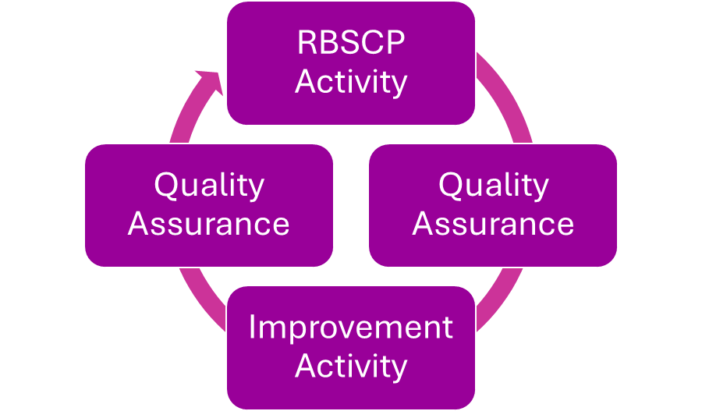

https://www.legislation.gov.uk/ukpga/2018/12/contents/enacted

