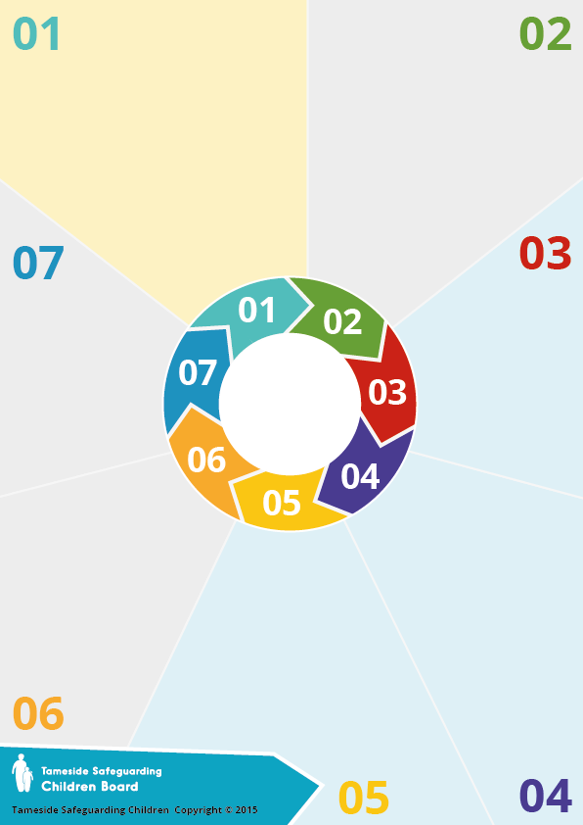

**Why it matters**

A 3 [year](https://mft.nhs.uk/saint-marys/uks-largest-study-on-non-fatal-strangulation-during-sexual-assault-findings/) study on non-fatal strangulation at Saint Mary’s Sexual Assault Referral Centre (SARC) in Manchester found that, of the 2,196 adults attending for a forensic medical examination following a report of rape or sexual assault:

* 1 in 11 said that they had also been strangled as part of the assault.
* This rose to 1 in 5 where the alleged perpetrator was a partner or ex-partner
* 40% were strangled in their own home
* 27% said their attacker had strangled them before this incident
* 15.7% were strangled until they had lost consciousness
* 36.6% thought that they were going to die
* Less than half had any external injuries as a result of the strangulation.

**Background:**

The lobby groups, We Can’t Consent to This (WCCTT) and the Centre for Women’s Justice (CWJ), called for a free-standing offence of non-fatal strangulation or asphyxiation in late April 2020.

The proposal for a new offence was strongly supported by both the Domestic Abuse and Victims’ Commissioners and numerous domestic abuse charities from around England and Wales.Non-fatal strangulation typically involves someone strangling or intentionally affecting their victim's ability to breathe in an attempt to control or intimidate them.

It has been made a specific offence as part of the

**Government's Domestic Abuse Act (2021).**



**Question**

**When did the offence come into force?**

The new offence came into force on 07.06.22 and perpetrators may face up to 5 years in prison if found guilty.

**Legislation: Domestic Abuse Act (2021)**

The Domestic Abuse Act 2021 amends the Serious Crime Act 2015, introducing two new sections — section 75A and 75B— which will create a new and specific criminal offence of non-fatal strangulation and suffocation

[The offence](https://www.gov.uk/government/publications/domestic-abuse-bill-2020-factsheets/strangulation-and-suffocation) will apply to any case where a person intentionally strangles or suffocates another person, including in cases of domestic abuse. The offence will also apply where strangulation or suffocation is committed abroad by a British national or by a person who is habitually resident in England or Wales, as if the offence had happened in England and Wales.

**Key Points**

# NFS is overwhelmingly male against female

# It is a very intimate crime, often committed face-to-face.

# Strangulation is more serious on lots of levels than many other forms of physical violence – which are of course serious in themselves. However, NFS poses many risks to the victims’ health, both immediate and longer term, due to the restriction of oxygen to the brain. It can also cause psychological damage and, crucially, is an important risk factor for [homicide of women.](https://www.ncbi.nlm.nih.gov/pmc/articles/PMC2573025/)

* Victims are seven times more likely to be murdered by their partner if there had been non-fatal strangulation beforehand.

# Strangulation and asphyxiation are the second most common method of killing in female homicides - 29% or 17% - as compared to only 3% of male homicides.



**Further reading:**

[Domestic Abuse Policy paper](https://www.gov.uk/government/publications/domestic-abuse-bill-2020-factsheets/strangulation-and-suffocation): Strangulation & suffocation

[Non-fatal strangulation:](https://fflm.ac.uk/wp-content/uploads/2020/03/Non-fatal-strangulation-in-physical-and-sexual-assault-Dr-C-White-Dr-M-Stark-Dr-B-Butler-March-2020.pdf) in physical and sexual assault

[MJA guide for GPs](https://insightplus.mja.com.au/2019/36/non-fatal-strangulation-a-guide-for-gps/) (2019)

**Non-fatal strangulation**

**(NFS)**