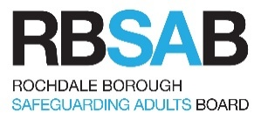

Multi-Agency Risk Management (MRM)
Protocol Guidance

This document is intended only as a brief guide to the MRM process. More detailed information can be found in the appendices on final page.

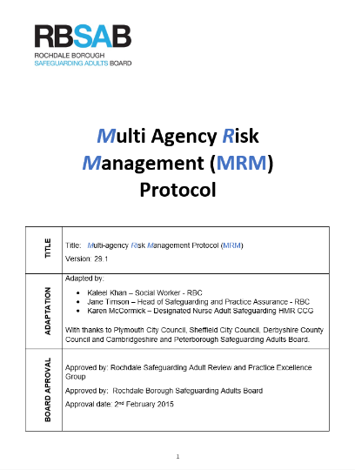
What does MRM mean?
MRM is an abbreviation for the Multi-Agency Risk Management Protocol.

What is the purpose of the MRM protocol?
The Multi-agency Risk Management protocol (abbreviated to MRM) is a layered framework designed to support risk identifying agencies through single agency, multi-agency and escalated support pathways. The protocol recognises that in some cases safeguarding risks can be owned and managed at a single agency level, whilst other complex cases require multi-agency activity.

It also recognises that some cases will be so complex that escalation to senior oversight will be required. RBSAB has learned from Safeguarding Adult Reviews many cases of this type lack ownership of safeguarding risks, effective sharing of information, plans are not formed with adults and escalation pathways not used consistently. The revised MRM protocol has considered and presented solutions to address these findings.

What is it about?
The protocol provides professionals with a framework to facilitate effective risk ownership and multi-agency working with adults who have mental capacity and who are at risk of serious harm or death through abuse or neglect, risk taking behaviour or refusal of services.

It aims to provide professionals from all Rochdale Borough Safeguarding Adults Board (RBSAB) partner agencies guidance for the management of complex cases where, despite ongoing work, serious safeguarding risks are still present.

The MRM is a multi-agency platform to discuss, identify and document risks for complex cases, and formulate an action plan identifying appropriate agencies responsibility for actions. It also provides a mechanism for review of the action plan and an escalation route if required.

The MRM is designed to allow multi-agency work to happen with an adult by allowing them to engage with professionals and inform of their preferred outcomes.

Is the MRM protocol suitable for all complex cases?
No, in cases where an adult has not had mental capacity evidenced, professionals should follow Assessing Capacity and Making Best Interests Decisions under the Mental Capacity Act (MCA). In some cases, an adult on the MRM framework may have fluctuating capacity, impaired capacity or capacity status changed. In these cases, the owners of risk must assess which support protocols should be followed.

Is the MRM protocol an alternative framework for Section 42 Care Act enquiries?
No, the MRM protocol should be used in all situations where there is concern that an adult with care and support needs, who has capacity, may be at risk of or experiencing abuse or neglect. If in doubt, please contact Adult Social Care on 0300 303 8886. On identifying a safeguarding risk, agencies must consider submitting a safeguarding concern via the Adult Social Care Portal. Please note that submitting a safeguarding concern does not discharge an agency safeguarding responsibilities to Adult Social Care. Identifying agencies should continue to follow the MRM protocol if the adult is thought to have capacity. Adult Social Care will provide advice on the outcome of safeguarding concerns.

Is the MRM a risk assessment?
No, MRM is a multi-agency protocol to allow informed conversations which will contribute to risk assessment. It is not a risk assessment tool and does not replace any other risk assessment tools that are being used in your agency/organisation. Partner organisations should ensure that they have the mechanisms in place to enable early identification and assessment of risk through timely information sharing and targeted multi-agency support.

Is the MRM Framework statutory?
No, the MRM framework is not in statute. It is a RBSAB developed and agreed framework. It needs to be placed in a context of the broad safeguarding umbrella where people may have come to harm or are at risk of doing so. The six principles of adult safeguarding should be considered in all cases where the MRM framework is utilised.

What are the six principles of safeguarding?
Six key principles underpin all adult safeguarding work, as laid down by the Care Act 2014. These are:

Empowerment – Personalisation and the presumption of person-led decisions and informed consent.
“I am asked what I want as the outcomes from the safeguarding process and these directly inform what happens.”

Prevention – It is better to take action before harm occurs.
“I receive clear and simple information about what abuse is, how to recognise the signs and what I can do to seek help.”

Proportionality – Proportionate and least intrusive response appropriate to the risk presented.
“I am sure that the professionals will work for my best interests, and they will only get involved as much as needed.”

Protection – Support and representation for those in greatest need.
“I get help and support to report abuse. I get help to take part in the safeguarding process to the extent to which I want and to which I am able.”

Partnership – Local solutions through services working with their communities. Communities have a part to play in preventing, detecting and reporting neglect and abuse.
“I know that professionals treat any personal and sensitive information in confidence, only sharing what is necessary. I am confident that professionals will work together to get the best result for me.”

Accountability – Accountability and transparency in delivering safeguarding.
“I understand the role of everyone involved in my life.”

What about engagement with the adult?
The responsibility to seek effective engagement is with the agencies involved with single or multi-agency support planning. This protocol does not seek to override an organisations engagement policies or procedures. Safeguarding Adult Reviews have provided learning that multi-agency planning should consider which organisations have formed professional relationships with the adult and are best placed to influence engagement with MRM related processes. SARs have also stated the importance of involving family, carers and trusted friends within assessment and planning processes. All professionals and multi-agency staff who work with adults at risk or manage safeguarding processes should apply Making Safeguarding Personal (MSP) principles. Applying MSP principles to MRM protocol will assist with engagement.

Is the Protocol new?
No, the MRM Protocol has been in place for a while – this is a re-launch with some significant changes influenced by Safeguarding Adult Review (SAR) learning. These are defined owners of risk and simplification of the pathway from identifying risk to escalation. Better defined requirements of multi-agency working and the ownership / leadership of multi-agency support offered. The changes made in the Rochdale Borough also closely align to processes used in other areas of Greater Manchester. This will allow for a consistency of expectation from RBSAB members providing a multi-area service.

The new Protocol replaces the previous RBSAB Multi-Disciplinary Teams (MDT) Protocol and the previous MRM Protocol. It will help professionals work together to support an adult who has capacity to make decisions about their care and support needs and the risk to their wellbeing would benefit from joint multi-agency management and when required, senior oversight of risk management strategies

This guidance does not seek to replace single agency risk management protocols, or legislative safeguarding processes. This guidance should be understood alongside the RBSAB Safeguarding Policy available at www.rochdalesafeguarding.com and single agency policies and expectations.

What is the layered approach?

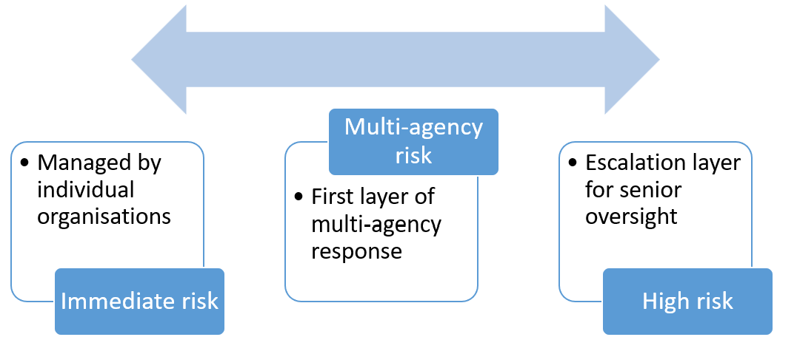

Immediate Risk – can be managed by individual organisations.
Immediate risks are the responsibility of individual agencies for early identification and working with the adult to inform immediate care, support and welfare requirements. In some cases, immediate risks may be considered low and managed at a single agency level with limited input from other agencies.

Multi-agency Risk – the first layer of multi-agency response.
Multi-agency risks occur when an individual has identified, or immediate risk assessment has identified, the support requirements from a range of services. Multi-agency risks may also occur when an individual adult frequently uses services or causes harm to others. When multi-agency risks occur, RBSAB expects those services, and specifically those practitioners supporting the adult, to convene multi-agency discussions to share information and jointly make an informed plan.

High-Risk - escalation layer for senior oversight.
The High-Risk layer allows for cases to escalate for senior management multi-agency oversight. Cases should be escalated where the practitioner layer of multi-agency response is evidencing:
- a case is highly complex,
- The multi-agency risk group have considered all aspects of MRM checklist
- the completion of “normal” multi-agency process has not been effective in improving outcomes for the adult,
- The adult is at immediate risk of death or severe harm
Meeting the above statements will allow a referral for senior manager oversight.

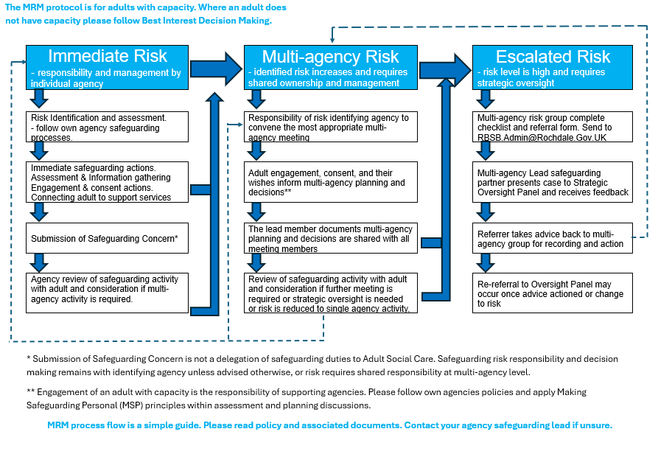
Who can arrange an Multi Agency Risk Meeting?
Any organisation can lead and arrange a multi-agency risk meeting, these meeting may also be known as MDT’s, strategy meeting or risk assessment meetings.

It is expected that the lead agency will:
- Provide appropriate and accessible meeting platforms and invite agencies who will provide a required level of support
- Provide the information and purpose of meeting in advance as appropriately identified per individual case
- Document conversations and share information in a timely manner
- Inform the adult of meeting and seek engagement in process as appropriate to the individual case
- Make arrangements for follow-up meetings or review of agreed actions

What should other agencies do?
It is an expectation that all agencies invited support the Multi-agency Risk meeting by:
- Attending the meetings or sending an appropriate deputy
- Sharing information in advance, or during the meeting, which includes MSP (Making Safeguarding Personal) information held
- Contribute to discussions actively and constructively to find solutions to help the Adult concerned
- Maintaining a person-centred, not organisational focus
- Complete any actions from the meeting in a timely manner
- Provide timely feedback and evidence of success of challenges to the lead agency

What happens at an Multi Agency Risk meeting?
The aim of a multi-agency risk meeting is to identify the multi-agency contributions which will mitigate or remove identified risks. It is to ensure the multi-agency approach is co-ordinated to achieve the best possible outcomes. The assessment, planning and forecasted outcome is agreed via engagement with the adult.

It is an entirely appropriate outcome of a Multi-agency Risk meeting that:
- A lead agency may change to one that has the best levels of skills, knowledge and expertise to lead and manage a case. If this occurs, it should be made by majority multi-agency agreement.
- Other agencies are identified and contacted to provide information or attend a meeting.
- Agreed actions are given a timescale, and the practitioner reconvene a review of success and further planning.
- Practitioners agree that a risk can be managed at the immediate risk level, agreement for this should be via multi-agency majority. The lead agency at immediate risk level should document agreed actions / outcomes and share information with partners. They should also consider any challenges and requirements to reconvene multi-agency risk meetings.
- Case requires step up to high-risk strategic oversight. The MRM checklist should be considered in event of this decision and lead MRM agency submit a referral to rbsb.admin@rochdale.gov.uk

Documentation, information sharing, timeliness of actions and evidence of need and outcomes are key to successful Multi-agency Risk meetings

What are the benefits of a multi-agency approach?
Multi-agency approaches with individuals who face multiple issues in their lives can improve outcomes for people who draw on care and support, including:
- Better information sharing to understand the multiple issues facing an individual that may be impacting on their engagement with support
- Better understanding where there may be barriers to treatment planning and compliance
- Better understanding of risks and shared action plans to address concerns to prevent escalation
- Potential reduction in service utilisation (hospital admission, A&E attendance, readmission and length of stay)
- Less duplication of services provided at home or close to home
- Greater self-management and better preventative care to stay well
- Improved experience for those who draw on care and support
- People’s engagement and activation through social prescribing and shared decision-making
- Greater continuity of care and support across different care settings.

What’s the Multi-Agency Strategic Oversight Panel?
The panel provides a multi-agency platform at a senior level to discuss individuals who are deemed to be at a significant high risk, at the point where a S42 enquiry and other multi-agency processes under the Care Act have not enabled the risks to be reduced or stabilised.

The Panel has an advisory and supportive function, and it should be noted that agency statutory duties and responsibilities remain with the relevant agencies. The panel acts to ensure that all statutory responsibilities have been met.

When should a referral to the Panel be made?
Referrals to the Strategic Oversight Panel process must only to be used where the adult:
- Has care and support needs (whether or not the local authority is meeting any of those needs) and is experiencing, or is at risk of, abuse, neglect or self-neglect.
- As a result of their care and support needs the adult is unable to protect themselves from either the risk of, or the experience of, abuse or neglect;
- The adult has mental capacity to make unwise decisions and choices about their life.
- The adult’s decision-making places them at risk of serious harm from self or others.
- There is documented evidence that the adult is not engaging with health and social care services to reduce the risk of harm or death and multi-agency responses have been unable to reduce the level of risk

NOTE: Further details on appropriate referrals can be found in the MRM Protocol 2026 (Appendix 1) – these should be consulted before a referral is made.

Panel meetings
The panel meets bi-monthly with each meeting being scheduled for no more than 2 hours. In exceptional circumstances the panel may need to meet in-between the monthly scheduled meeting to discuss a particularly urgent case. These meetings will be kept to a minimum, and consideration will be given to the required make-up of the Panel for such a meeting.

It should be noted that the panel is not an appropriate forum for responding to emergency situations. Agencies have their own procedures to respond to these, and the panel offers more of a reflective review of a situation and is not intended as an emergency response.

How should a referral be made?
Once it has been agreed that a panel referral is appropriate the following steps should be taken.
- Complete Referral form (Appendix 3) and email to rbsb.admin@rochdale.gov.uk
- Include minutes of previous multi-agency meeting

Appendices

Appendix 1  MRM Protocol 2026 | 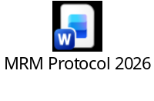
Appendix 2  Consideration Checklist | 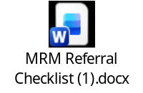
Appendix 3  Referral Form for Multi-Agency Strategic Oversight Panel | 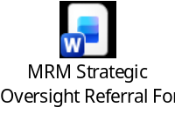
Appendix 4  Agenda for Strategic Oversight Panel | 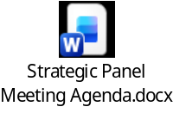
Appendix 5  Key legislation | 
Appendix 6  Practical Guide to Assessing Capacity | 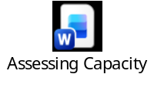
Appendix 7  What happens when I raise a Safeguarding Adult concern? | 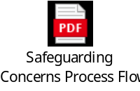
Appendix 8
Additional Information
- Multi-Agency Safeguarding Policy and Procedures
- Safeguarding Adult Reviews
- 7 Minute Briefings
- Professional Curiosity Pack
- Safeguarding Training

