Mental Health Support

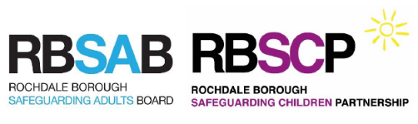
Adults - where to get mental health support
- Alzheimer's Society - offering information, support and advice on coronavirus for adults with dementia. In particular, they try to help if dementia makes it difficult for you or your loved one to follow NHS or government advice.
- Every Mind Matters - get ideas and advice for improving your mood at home.
- OCD-UK - advice and coronavirus survival tips for adults with OCD (obsessive compulsive disorder).
- Public Health England - guidance on how to look after your feelings and your body in self-isolation.
- Rochdale and District Mind - over the phone help and online support groups for all adults.
- Shout - anyone 16 years or older who's experiencing mental health challenges can access a free text message helpline. You can send a text message any time of day or night wherever you are. Every conversation is with a human being.
- Thinking Ahead - you can access online or over the phone therapy to help you with any mental health difficulties.
Children and teenagers - where to get mental health support
- Anna Freud - young people can get help dealing with worries about how coronavirus will affect loved ones.
- Covibook - children under 7 years old can use this interactive resource to help them explain and draw the emotions that they might be experiencing during the pandemic.
- Kooth - children and teenagers aged 11-18 can use this confidential and anonymous online counselling and emotional wellbeing service.
- The National Autistic Society - children on the autism spectrum, including those with Asperger syndrome can access advice, tips and links to further resources on dealing with anxiety.
- Young Minds - help for teenagers who are anxious or scared about coronavirus.
Parents - where to get help to support your child's mental health
- Anna Freud - resources on how to talk to your children about coronavirus and how to help them with any worries they might have.
- Beyond Psychology - online workshops for parents and carers about helping young people and children understand and manage their anxiety, stress and emotional behaviour. The workshops are FREE but you need to register for an account.
- Government advice - parents and carers who need help supporting their child's mental health can access self-help tips and links to further support.
- Greater Manchester Health and Social Care Partnership - access a list of local and national services who offer mental health support for parents.

