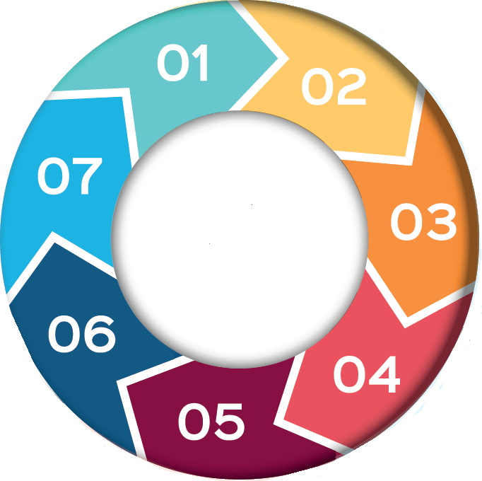

The Act states that a person can make a decision for themselves if they can do the following:
- Understand the information given to them
- Retain the information long enough to make the decision
- Weigh up the information available to make the decision
- Communicate their decision
Nothing in the MCA 2005 allows for the following decisions to be made on behalf of an individual: Marriage, civil partnership or divorce; sexual relations, adoption, parental responsibility: voting rights.

7 Minute Briefing: Mental Capacity Act (2005)
Recording What and when to record will vary. As a general rule, there is no need to record assessments of capacity to take day-to-day decisions, e.g. what drink to have/what to wear. BUT, for more serious, life changing decisions, a formal assessment is needed. If you have proper reason to think that the person may lack capacity to take a relevant decision, especially if the consequence of what they are wanting to do is likely to lead to serious consequences for them, it is not enough to record that they ‘have capacity’. The more serious the issue, the more need to document the risks that have been discussed with the person and the reasons why it is considered that they are able and willing to take those risks.

RBSAB MCA resources
The Act has a two-stage test for assessing capacity:
Stage 1 – Is the person unable to make a particular decision (the functional test)?
Stage 2 – Is the inability to make a decision caused by an impairment of, or disturbance in the functioning of, a person’s mind or brain? This could be due to long-term conditions such as mental illness, dementia, or learning disability, or more temporary states such as confusion, unconsciousness, or the effects of drugs or alcohol (the diagnostic test).

If capacity is in doubt we must assess and determine:
- P has capacity to make a specific decision, therefore a capacitated unwise decision = harm reduction & risk mitigation actions
- P lacks capacity to make a specific decision = an MCA best interest process …This is a growing theme in serious case reviews nationally..

The MCA has five statutory principles:
1: Presume capacity: unless proven otherwise 2: Support to make decisions: take all reasonable steps to enable a person to make their own decision. 3: Unwise decisions: do not assume incapacity, simply because a person makes an unwise decision. 4: Best interests: decisions made on behalf of someone lacking capacity must be in their best interests. 5: Least restrictive: any decisions made must be the least restrictive option.
Howew
Further reading:
Mental Capacity Act Code of Practice

Carrying out and recording mental capacity Assessments

Bournemouth University Mental Capacity toolkit

www.capacityguide.org.uk - Guidance for clinicians and social care professionals on the assessment of capacity
MCA in Practice

Principles 1 & 3 are frequently misunderstood
Principle 1: People might be assumed to have capacity, when they don’t (and it’s not assessed), even though there is doubt. We MUST NOT misinterpret Principle 1 and ‘hide behind the presumption of capacity’, leaving someone at risk.
Principle 3: Professionals may inappropriately argue that people’s unwise actions reflect their ‘right’ to live in a risky way… this is a misinterpretation of Principle 3 and can lead to unfounded conclusions like ‘There’s nothing more for us to do’ and subsequent discharge or withdrawal of service.

The Mental Capacity Act (MCA) 2005 is a legal framework which applies to individuals over the age of 16, who may lack the mental capacity to make specific decisions about their life and for themselves, whether on a permanent or temporary basis. These decisions can range from everyday things like choosing what to wear or eat, to more complex considerations such as deciding where to live or receiving medical treatment.
The Act is in place to empower and protect individuals who may lack capacity by placing them at the centre of the decision-making process.

Background
Cannabis is a hallucinogenic drug. It is also known as weed, hash, marijuana and pot. Cannabis can be taken in a variety of ways; smoked mixed with tobacco in a cigarette or bong, mixing into edibles such as cake or sweets or vaped.
The strength of cannabis on the market has increased significantly over the past 20 years.
The effects of cannabis can vary widely, some people feel relaxed, happy and giggly, others feel paranoid, anxious or confused.
abis on the market has increased significantly over the past 20 years.
The effects of cannabis can vary widely, some people feel relaxed, happy and giggly, others feel paranoid, anxious or confused.
abis on the market has increased significantly over the past 20 years.
The effects of cannabis can vary widely, some people feel relaxed, happy and giggly, others feel paranoid, anxious or confused.

