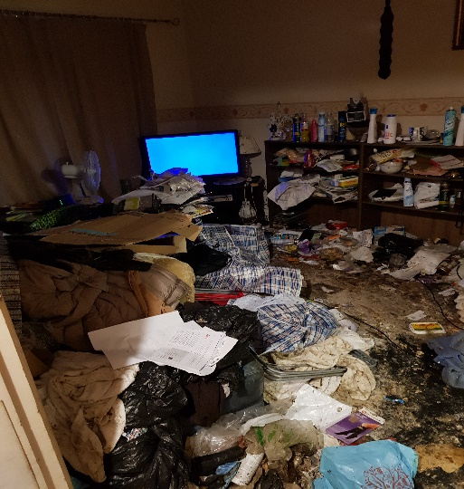

**Hoarding - Safety Tips**

## If you store large amounts of possessions in and around your home, you can help keep yourself safe from fire by following the advice below. Our ‘top tips’ are small, simple steps that can easily be included in your regular weekly/daily clearance sessions.

**For more help or to arrange a Safe and Well Visit:**

**Greater Manchester Fire and Rescue Service Contact Centre: 0800 555 815**

* Plan and practise how to escape from your home in case of a fire. Choose an escape route and keep it clear of possessions – in the event of a fire this will help you to escape quickly or allow fire fighters to reach you if you are unable to escape.
* Ensure possessions are stored on stable surfaces and do not stack items to a height that they become unstable – they could fall over blocking your escape.
* Newspapers and mail stored in bulk are highly combustible and will cause a fire to spread rapidly. Sort mail and newspapers on the day you receive them and recycle them on a regular basis.
* In the event of a fire, do not attempt to put it out yourself – leave your home straight away and call the fire service once you are safely outside.

Do not stop on your way out to collect possessions and do not go back inside once you have escaped.

* If you feel that you need some help or assistance with the above, there are many organisations that will support you through the process.
* Whether you use a traditional oven/hob, or other methods of cooking such a portable stove, make it a priority to keep the cooking area clear.
* Do not place items on or close to heaters, lamps or other electrical equipment.
* Do not store cylinders in your home as they are a serious hazard during a fire. If you have a medical need for cylinders, they should be kept upright and outdoors where possible – never store cylinders in basements, under stairs or in cupboards with electric meters/equipment.
* If you smoke, use a proper ashtray that won’t burn and put it on a flat, stable surface so that it can’t tip over easily. Don’t leave your lit cigarettes unattended.
* Put candles/tea lights in heat resistant holders that hold the candle/tea light firmly and ensure it is placed on a flat, stable, heat resistant surface.
* Make sure you have working smoking alarms and test them as part of your regular clearance sessions. You can contact Greater Manchester Fire and Rescue Service for advice: 0800 555 815