There is no statutory definition of Honour Based Abuse

(HBA) but in Rochdale, we use the following definition:

**HBA is ‘a collection of practices used predominantly to control**

**the behaviour of women and girls within families or other**

**social groups to protect supposed cultural and religious beliefs,**

**values and social norms in the name of ‘honour’**.

The charity, [Karma Nirvana](https://karmanirvana.org.uk), is campaigning for a statutory

definition of HBA. You can read their definition, along with a

briefing about why a statutory definition is important, [here](https://karmanirvana.org.uk/get-help/professionals/honour-based-abuse-and-karma-nirvana/).

**Useful contacts and resources:**

* **Immediate risk - Contact the Police on 999**
* **Rochdale** [**Adult Safeguarding**](https://staywell.rochdale.gov.uk/web/portal/pages/adultcare/reportabuse) **-** Contact 0300 303 8886
* **Child Safeguarding –**[**EHASH**](https://www.ourrochdale.org.uk/kb5/rochdale/directory/service.page?id=B5VrwASyDAk)Contact 0300 303 0440
* [**Rochdale Women’s Welfare Association**](https://www.rwwa.org.uk/)01706 860157
* Greater Manchester [**Lotus Hub**](https://www.endthefear.co.uk/2023/11/16/the-launch-of-the-new-dva-service-the-lotus-hub/) **-** 07894443756
* [**Karma Nirvana**](https://karmanirvana.org.uk/get-help/helpline/) **national helpline** 0800 5999 247

**Guidance**

* [Forced Marriage Statutory Guidance](https://www.gov.uk/government/publications/the-right-to-choose-government-guidance-on-forced-marriage/multi-agency-statutory-guidance-for-dealing-with-forced-marriage-and-multi-agency-practice-guidelines-handling-cases-of-forced-marriage-accessible)
* [FGM Statutory Guidance](https://www.gov.uk/government/publications/multi-agency-statutory-guidance-on-female-genital-mutilation)
* [GM Safeguarding Children Procedures](https://greatermanchesterscp.trixonline.co.uk/contents/contents) (HBA/Forced Marriage/FGM and [culturally appropriate practice](https://greatermanchesterscp.trixonline.co.uk/chapter/guidance-for-culturally-appropriate-practice))

**7 Minute Briefing**

**Honour Based Abuse**

In the year ending [March 2023](https://www.gov.uk/government/statistics/so-called-honour-based-abuse-offences-2022-to-2023/5117ed88-dd93-4f1c-a7b9-ce3e26006846), 2,905 HBA-related offences were recorded by the police in England and Wales, equivalent to around **7 cases every day.** Offences included: controlling and coercive behaviour (19%), assault with injury (16%), assault without injury (12%), forced marriage (5.9%), FGM (2%). HBA is largely a hidden crime as victims take huge risks in reporting the crimes against them. The Home Office recognises, that the police data is “likely to only represent a small proportion of the actual HBA offences committed. Karma Nirvana maintains an [interactive map](https://karmanirvana.org.uk/data/interactive-map-of-honour-based-abuse-deaths-in-the-uk/) of HBA killings in the UK.

[**Girls and women**](https://journals.sagepub.com/doi/full/10.1177/1077801220952168) **are most at risk of HBA.**

**But** [**males**](https://journals.sagepub.com/doi/full/10.1177/0886260521997928) **can be victims too** [BBC Newsnight](https://www.youtube.com/watch?v=NQVSmDpueVc) – male victims

Behaviours which may be perceived as breaching ‘honour’ codes will vary between families and communities but may include:

* Refusing an arranged marriage
* Relationships outside the approved group
* ‘Inappropriate’ make-up or dress
* Identify as [LGBTQ+](https://galop.org.uk/types-of-abuse/other-forms-of-abuse/honour-based-abuse/#:~:text=Honour-based%20abuse%E2%80%AFagainst%20LGBT%2B%20people%20happens%20when%20family%2Fcommunity%20members,of%20a%20range%20of%20abusive%20behaviours%20and%20practices.)

**Recent research suggests** [**three HBA perpetrator ‘types’.**](https://www.tandfonline.com/doi/full/10.1080/24732850.2024.2390872)

HBA can occur within any community and is not

a mainstream practice of any specific religion or culture.

**HBA can take many forms** **and include multiple crimes** e.g. female genital mutilation (FGM), forced marriage, false imprisonment, abandonment, breast flattening,

and other forms of domestic abuse perpetrated in a

perceived defence of ‘honour’, including ‘honour’ killings. Watch [Banaz: An Honour Killing](https://www.youtube.com/watch?v=Qn-VhFHkUoY)

[Research (2022)](https://onlinelibrary.wiley.com/doi/10.1002/jip.1602) has identified emotional/ psychological abuse & coercive control as the most common forms of HBA in the UK. **The motivating factors behind the abuse identify it as honour-based, rather than the abuse itself.**

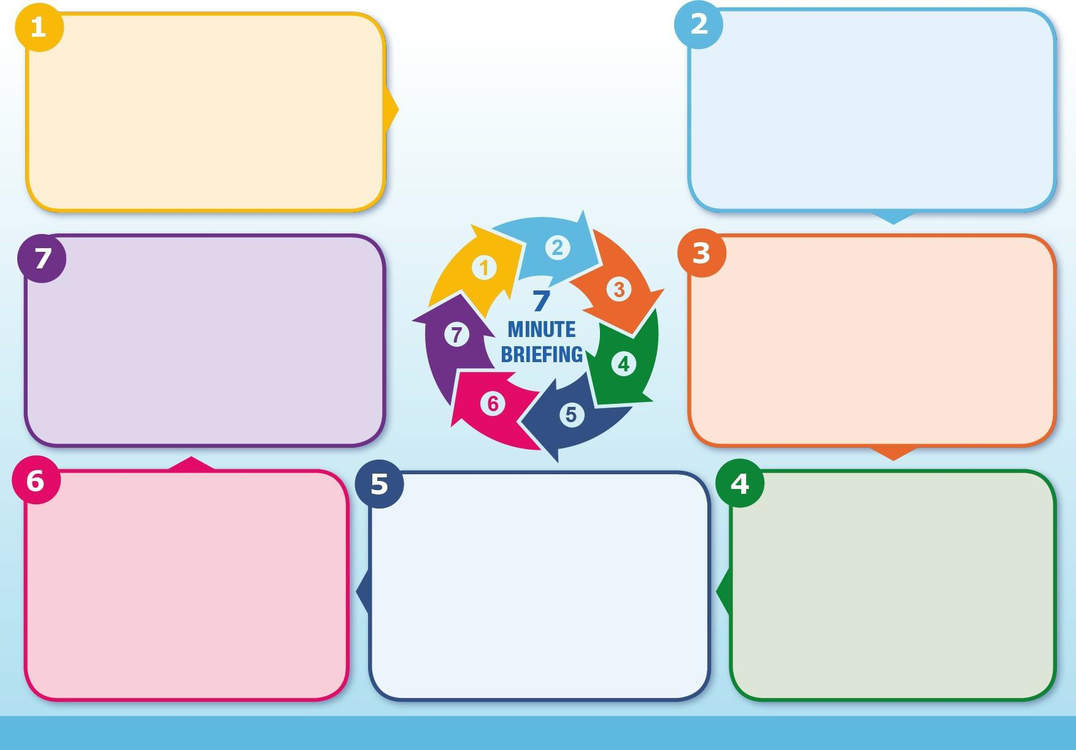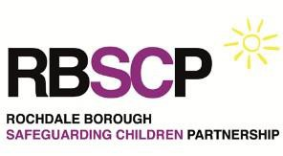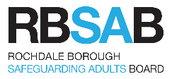

**Support for victims:**

There are a range of measures available to support and

protect victims of HBA, including statutory child and adult

safeguarding procedures, [domestic abuse services](https://www.rochdale.gov.uk/domestic-violence-abuse) and support

from specialist charities.

Other measures include:

[Forced Marriage Protection Orders](https://www.gov.uk/government/publications/forced-marriage-protection-orders-fl701/forced-marriage-protection-orders) ; [FGM Protection Orders](https://www.gov.uk/government/publications/female-genital-mutilation-protection-orders-fgm700/female-genital-mutilation-fgm-protection-orders)

[Non-molestation orders](https://www.gov.uk/injunction-domestic-violence/eligibility-non-molestation) ; [Domestic Violence Protection Notices](https://www.gov.uk/government/publications/domestic-violence-protection-orders/domestic-violence-protection-notices-dvpns-and-domestic-violence-protection-orders-dvpos-guidance-sections-24-33-crime-and-security-act-2010) & [Domestic Violence Protection Orders](https://www.gov.uk/government/publications/domestic-violence-protection-orders/domestic-violence-protection-notices-dvpns-and-domestic-violence-protection-orders-dvpos-guidance-sections-24-33-crime-and-security-act-2010) (DVPOs).

HBA is complex; concepts of ‘honour’ and types of abuse

will vary, both within and across different communities –

always seek advice; including from specialist agencies, to

effectively support and protect victims.

.

[**ONE CHANCE RULE**](https://www.saverauk.co.uk/1-chance-rule/#:~:text=1%20Chance%20Rule%20The%20%E2%80%98One%20Chance%20Rule%E2%80%99%20is,female%20genital%20mutilation%2C%20breast%20ironing%20and%20virginity%20testing.)

**Never turn a person away!**

You may only have ONE CHANCE to speak to a potential victim and may only have ONE CHANCE to save a life!

* Believe the victim.
* Do not involve or speak to family or community members.
* Use professional curiosity when assessing risk and safety planning.
* Consider additional complexities and adversities such as: immigration status, language, disabilities, mental capacity and sexuality.

.