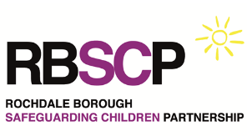
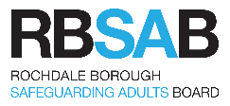
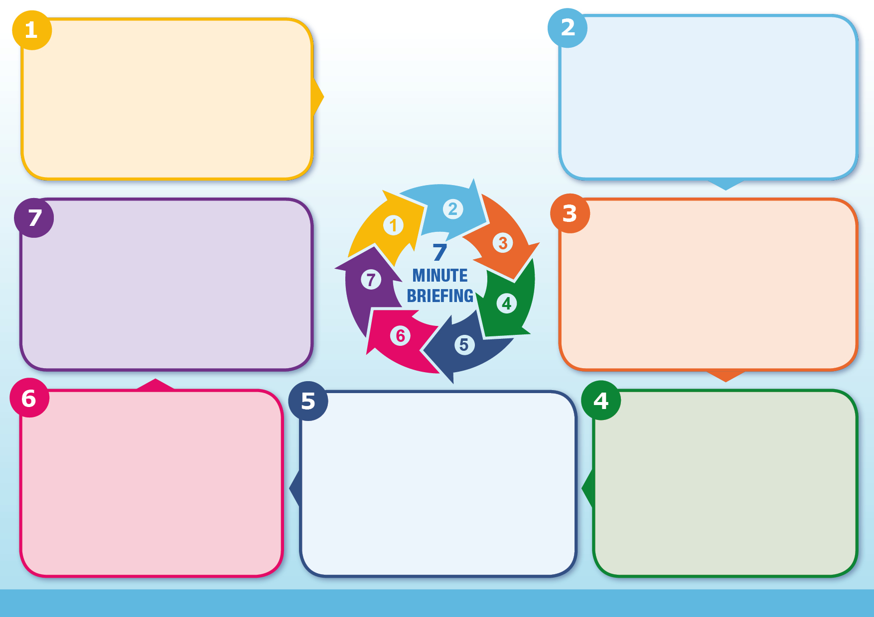
Refer to Greater Manchester Safeguarding Children Procedures and RBSAB Safeguarding Adults Procedures

Follow FGM protocol when disclosure of female genital mutilation, for further support contact Nestac - enquiries@nestac.org.uk 0161 975 6009
For advice on Forced Marriage, contact Forced Marriage Unit (FMU) – fmu@fcdo.gov.uk 0207 008 0151
Immediate risk – call 999 or 101 (non emergencies’)
Remember for a young person under the age of 18 HBVA is a child protection issue
Additional Information
Take all disclosure seriously and understand the voice of the victim. Assure the person that you will treat the information with confidentiality and only share with selected safeguarding officers who are able to help and advice, look at the:
THREAT
RISK
HARM
You may have the one chance to save a life.
Never try to mediate with family and or community
What to do
Honour base violence and abuse can manifest in different ways for each family and community so it’s important that you treat each case as an individual case and not assume that all cases are the same and should be dealt alike. Make sure you carry out a thorough assessment and establish any family history of HBVA in the UK or and abroad. Look at holding a strategy meeting or a multiagency meeting to gather further information. Think about the family, ext.-family, and community to establish who can be a danger/threat to the victim.
When working with victims it is important to establish secure and confidential contact at the earliest opportunity as you may not have another chance to get information or to see the person again.
Things to consider
Crimes committed in the name of “Honour” includes.
⬥ Domestic violence and abuse  Sexual abuse
⬥ Rape  Virginity testing
⬥ Hymenoplasty  Psychological abuse
⬥ Female genital mutilation  Murder
⬥ Acid attack  Threats and verbal abuse
⬥ Forced marriage  Forced abortion
⬥ Stalking and Harassment
Many of these crimes can be committed by more than one person from the family and or community, this also may mean certain areas be unsafe for a victim. Think about the area and surroundings when placing a person in safety
Crimes committed
Honour based violence and abuse can exist in any culture where men are able to control women and can also be part of the gang culture, HBVA does not discriminate on race, religion, or culture. although most cases in the UK that has been recorded involve south Asian community which also reflects our large Asian community in Bury.
Think about all the other communities that exists in your locality
⬥ Kurdish Iranian  Middle eastern
⬥ African  South and Eastern European
⬥ Romanian  Traveller community
Note not all perpetrators may not be males so do not underestimate older females of the family as they can also equally be part of the abuse.
HBA and Culture/Religion
In the year ending March 2024, there were 2,755HBA-related offences recorded by the police in England and Wales. These figures do not take in count victims that have been taken abroad these are mainly women and girls. It is recognised that HBVA is a hidden crimes and victims can be reluctant to report to the police or local authorities due to fear. Victims of HBVA may find it hard to understand what HBVA is as the practices are embedded within their upbringing and culture, so its important that practitioners are able to understand and recognise the signs, symptoms, and motivation. Remember HBVA is not a part of any religion, look at the crime not the culture. Home office figures suggest that it is estimated that a HBVA killing takes place every 12 minutes globally.
Why it matters
These are collection of practices used to control a person’s behaviour within families and affected communities, in order to protect perceived cultural and religious beliefs and or honour. The use of abuse and violence can be used when perpetrators perceive that a person has brought shame or embarrassment to the family and or community and breaking the families or communities honour code.
Although Girls and women are most often the victims of honour-based violence and abuse it’s important to note boys and men can also be affected.
What is “Honour” Based Abuse?
“Honour” Based Abuse

