Briefing - FGM Mandatory Reporting

As you will be aware, the new professional duty to report cases of FGM in girls under the age of 18 to the police commenced on 31 October 2015.

A package of support has been made available by the Department of Health which may be of interest, including:

• Quick guidance – a 2-page summary of the duty including a process flowchart
• Poster – a poster for health organisations to display about the duty
• Training slides – a training presentation for organisations to use to help them deliver 10 – 15 minute updates to staff to explain the duty
• Video interviews with Vanessa Lodge, NHS England National FGM Prevention lead

An information leaflet for individuals and their families which professionals can use to help when discussing making a report to the police.

The website for written materials is: https://www.gov.uk/government/publications/fgm-mandatory-reporting-in-healthcare

Please access these links and download the materials. More materials and updates are also in the pipeline.

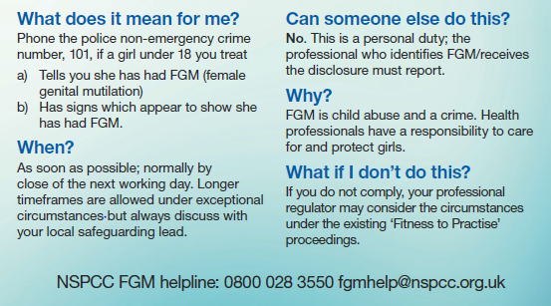
Please recirculate this email, these links, and these documents as widely as you can within your organisation and to other professionals.

Please note that a woman over the age 18 presents that she is at risk of FGM, this needs to be treated as a safeguarding concern.

