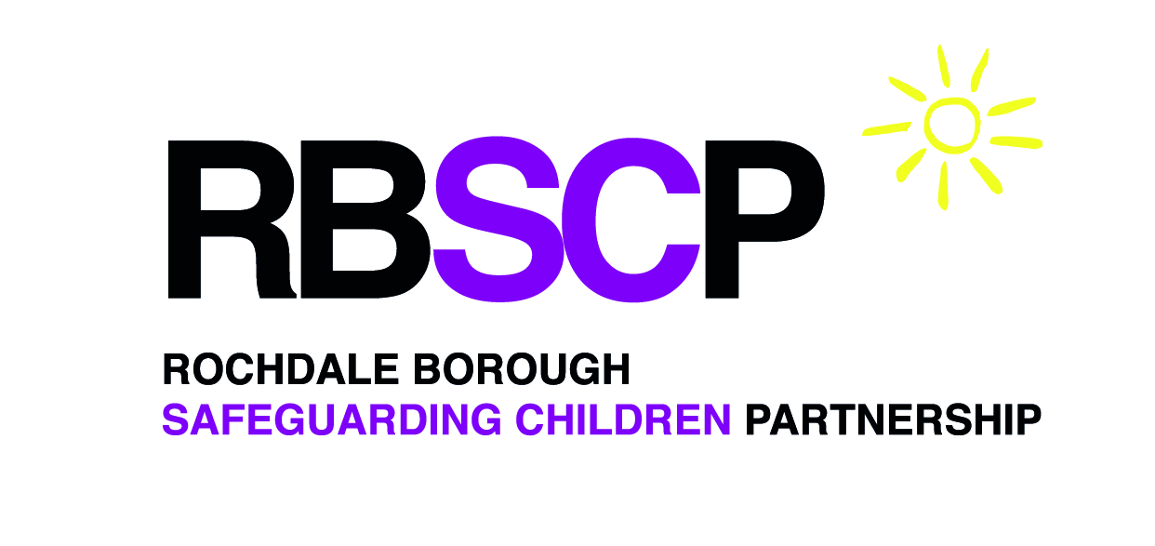
Data Sharing Agreement (DSA)

Between

Rochdale Borough Safeguarding Children Partnership
and

Safeguarding Partners
- Rochdale Borough Council - RBC (Local Authority)
- Heywood, Middleton and Rochdale Clinical Commissioning Group
- Greater Manchester Police (GMP)

Commencement, Termination and Review – This agreement will be reviewed every 36 months unless an earlier review is necessary.

The start date for this agreement is at the point of agreement.

Memorandum of Understanding
The parties to this Data Sharing Agreement (DSA) are signatories to this Memorandum of Understanding. The Parties acknowledge that they are Joint Data Controllers (as defined in the GDPR). The Memorandum of Understanding sets out the principles of Information Governance that all organisations who provide, access and use information have agreed to. It provides a framework for safeguarding the processing of data and information as defined by the Data Protection Act 2018 and General Data Protection Regulation (GDPR).

General Principles
- All signatories to the agreement agree to process personal information in accordance with their organisation’s information governance policies and procedures, or as directed by the standards applicable to the information being processed.
- Organisations are expected to identify and use appropriate information assurance frameworks and will commit to complying with relevant standards within that regime and sharing the evidence attainment and any associated action plans on request to the other parties to the agreement.
- Each organisation shall have appointed a responsible / accountable officer who will ensure the protection of personal information, for example a Caldicott Guardian, Data Protection Officer or Senior Manager responsible for data protection.
- Each organisation will take appropriate organisational and technical measures towards compliance with the Data Protection Act 2018, Caldicott Principles (where applicable), Information Security Standards, Freedom of Information Act 2000 (where applicable) and national guidance and rules around the processing of personal, confidential information and other relevant legislation.
- Each organisation is committed to risk assessing and documenting their processing activities and identifying any actions required to mitigate identified risk.
- Each organisation is committed to ensuring that staff are appropriately trained and comply with organisational policies in relation to Information Governance, including Data Protection, Confidentiality, Caldicott Principles (where applicable), Data Security, Records Management and Freedom of Information (where applicable).
- Organisations will promptly notify other partner organisations of any Information Governance Breach, vulnerability or threat that could affect the security of the data being shared – within 24 hours of becoming aware of it.
- Organisations will agree to allow partner or lead organisations to carry out audits or visits to confirm compliance with the agreed assurance requirements.
- Each organisation commits to ensure that data is shared in a safe and secure manner meeting the agreed purpose of the sharing and protecting the rights and freedoms of individuals.
- Any requests for information under the Freedom of information Act 2000 or Data Protection Act 2018 should be directed to the original organisations senior responsible officer.
- Organisations may not create or establish on-ward sharing for additional purposes without having a lawful basis to do so and the agreement of the original data controller.

Parties Named in this Agreement
The Parties listed below recognise their responsibilities for ensuring this agreement complies with all legislation and other requirements relevant to the personal data being shared, including the specific governance measures set out in this DSA. Any successor body of an organisation listed will be automatically added as a party the agreement.

Organisation | Responsible Senior Officer | Data Protection Officer or equivalent
Rochdale Borough Safeguarding Children Board | Amanda Clarke – Independent Chair | DPO@rochdale.gov.uk
Rochdale Borough Council | Sharon Hubber – Director of Children’s Services | DPO@rochdale.gov.uk
Heywood, Middleton and Rochdale Clinical Commissioning Group | Alison Kelly - Chief Nurse  Associate Director Quality and Safeguarding | hmrccg.dpo@nhs.net
Greater Manchester Police - Rochdale District | Nicky Porter – Chief Superintendent | dataprotection@gmp.police.uk

The Responsible Senior Officers named above provide assurance that:
- The details captured in this Data Sharing Agreement accurately describe the data sharing practices and the controls in place to govern them.
- Their organisation and its staff will make every effort to ensure that the controls are monitored and maintained and data sharing will only happen as described herein.
- Should their organisation wish to deviate from the practices and controls described here, they will review the data to ensure the changes are captured.

This information is held by the RBSCP and specifically for the purposes detailed in this agreement.

Purpose and Justification for Sharing

Purpose
The Parties agree to use shared information only for the specific purpose set out in this document and to support the effective administration, audit, monitoring, regulatory inspection of services and reporting requirements including:
- Child Death Review Partner arrangements
- Child Safeguarding Practice Review Panel

The Parties accept that shared information shall not be regarded as general intelligence for the further use by recipient organisations unless that further purpose is defined in this agreement.

This Data Sharing Agreement (DSA) supports the sharing of personal data to comply with statutory guidance Working Together to Safeguard Children. This is a framework for the three local safeguarding partners (the local authority, clinical commissioning group(s) and the chief officer of police for a police area(s) to make arrangements to work together to safeguard and promote the welfare of local children including identifying and responding to their needs:
- protecting children from maltreatment
- preventing impairment of children's health or development
- ensuring that children grow up in circumstances consistent with the provision of safe and effective care
- taking action to enable all children to have the best outcomes
- understanding the collective needs of children locally when commissioning services
- assisting with the management of risk that an individual may pose to a specific child or children.

To fulfil this role, the three safeguarding partners must set out how they will work together with any relevant agencies whose involvement the safeguarding partners consider may be required to safeguard and promote the welfare of children with regard to local need.

This includes a requirement to ensure that information is shared effectively to facilitate more accurate and timely decision making for children and families. Separate arrangements will be put in place to facilitate this case by case sharing with relevant agencies.

Benefits
The benefits derived from this information sharing agreement are identified as:
Safeguarding partners may require any person or organisation or agency to provide them with specified information which enables and assists the function to safeguard and promote the welfare of children in their area.
Enable the RBSCP to perform its functions including assessing the effectiveness of the arrangements.
Improving the speed and efficiency of information sharing to improve outcomes for children and young people in line with national and organisational information sharing procedures.

Restrictions on Further Use and Disclosure
It is recognised that unless the law specifically requires or permits this, shared information will not be used for different purposes or further disclosed. Even where the law permits further disclosure, in line with good practice, the originating data controller will be consulted first and depending on the circumstances, it may be necessary for the data subject to be informed of the disclosure.

The Information Being Shared
The types of information being shared under this agreement are identified as:
- Personal Data
- Special Category Data
- Criminal Offence Data

Categories of data subjects
- Children
- Customers or prospective customers
- Friends and Family Members
- Employees
- Patients
- Students
- Subscribers
- Vulnerable adults e.g. identification of a specific characteristic
- Offenders

Categories of data
- Basic personal identifiers, e.g. name, address, contact details
- Age/DOB
- Criminal convictions, offences
- Data revealing racial or ethnic origin
- Economic and financial data, e.g. credit card numbers, bank details
- Attainment or Educational Data
- Gender reassignment data
- Genetic or biometric data
- Health or Medical Records including disabilities
- Identifiers e.g. Account Number/ID, NI Number, Passport Number, Driving Licence Number
- Official documents, e.g. driving licences
- Photographs
- Political opinions
- Religious or philosophical beliefs
- Sex life data
- Sexual orientation data
- Trade union membership

A wide range of information has the potential to be processed due to nature of the processing.

Information Security & Confidentiality
The RBSCP functions with support from the Council with specific reference to the administration and management of data and systems upon which it relies. Information relating to cases and reviews is held centrally on Council systems which are secured and have limited access.

The Council holds information from all partners and organisations who have provided information under the direction of the RBSCP.

This DSA recognises that information sharing decisions should be recorded by the disclosing agency/organisation.

Where an agency/organisation has decided not to share information that has been requested, that agency/organisation will provide a record of the reasons for the decision not to share the information, including the consideration of the safety and well-being of the affected individual.

Data Protection Impact Assessment

Lawful Basis for Processing Information

Statutory duty / power to share
The legislation and/or regulations providing a mandatory duty or discretionary express or implied power for each of the partners to the agreement to share personal data for the purpose in this agreement include, but are not limited to:
- Children Act 1989
- Children Act 2004
- Working Together to Safeguard Children (Statutory Guidance)
and any subsequent updates or amendments to legislation or guidance.

GDPR Legitimising Conditions
The Article 6 conditions relied on for this agreement are:
(c) Legal obligation: the processing is necessary for you to comply with the law (not including contractual obligations).
(d) Vital interests: the processing is necessary to protect someone’s life.
(e) Public task: the processing is necessary for you to perform a task in the public interest or for your official functions, and the task or function has a clear basis in law.

The Article 9 conditions relied on for this agreement are:
(b) necessary for the purposes of carrying out the obligations and rights of the controller or data subject in the field of employment, social security and social protection law
(c) necessary to protect the vital interests of the data subject or of another person where the data subject is physically or legally incapable of giving consent
(g) necessary for reasons of substantial public interest which is proportionate to the aim pursued
(h) necessary for the purposes of preventive or occupational medicine, for the assessment of the working capacity of the employee, medical diagnosis, the provision of health or social care or treatment or the management of health or social care systems and services

Data Protection Act 2018
- Schedules 1 - 4
- Law Enforcement Processing – Part 3 and Schedule 8.
Informing Individuals
The privacy notice / amendments relevant to this data sharing arrangement are:
Data should only be handled in a way that the data subject would reasonably expect and not used in a way that would have an adverse effect on them. A Privacy Notice has been published on the RBSCP website.
Adequacy, relevance, necessity
The following checks have been made regarding the adequacy, relevance and necessity for the collection or sharing of data:
The GDPR protects the fundamental rights and freedoms of natural persons and in particular their right to the protection of personal data. The processing must represent a reasonable and proportionate way of achieving the purpose.
Information will be processed (predominantly) on a case by case basis with a decision taken by the providing organisation relating to the information to be shared. This is supported by guidance including Working Together to Safeguard Children and best interests’ considerations.
Organisations should share as much information as is required to address the safeguarding issue.
Provisions for the accuracy of the data
The following provisions have been made to ensure information will be kept up to date and checked for accuracy and completeness by all organisations.
The data has already been collected by the safeguarding partners or other relevant agencies as part of their functions. This will include historic data.
On a case by case basis, where required, additional due diligence documentation will be requested by the RBSCP where there is a need to obtain further assurance or clarification on the accuracy of the data.
Adequate initial information will be provided to the providing organisation to ensure that an accurate ‘match’ can be made.
Retention and disposal requirements
The following arrangements have been made to manage retention and disposal of data by all organisations
Information is only retained while there is a need to keep it, and destroyed in line with retention schedules, guidelines and Data Protection Legislation.
Individual rights
Subject Access and other Data Protection requests will be dealt with as follows:
In line with information in the Memorandum of Understanding using procedures and ICO guidance.
Any upheld complaints relating to information shared will be notified to any recipients of the data e.g. a request for rectification or erasure of data.
Technical and organisational measures
Organisational and technical security controls to support the processing of this data are in place across all organisations including:
- Technical security controls and PSN accreditation
- Secure transmission of data e.g. secure email
- Signed confidentiality agreements for meeting attendees – under need to know principles
- Case specific agreements for relevant agencies
- Access controls in place to protect information provided on secure network drives
- System log-ins
- Training and guidance for staff processing information
- Retention and destruction procedures
- Individual rights procedures
- Security breach procedures

Dispute Resolution
Each agency/organisation undertakes to pursue a positive approach towards resolving any dispute which maintains a strong working relationships. Each agency/organisation will use all reasonable endeavours to identify a mutually acceptable solution.
In the event of a dispute in relation to the agreement, the RBSCP Chair will investigate and determine any steps that need to be taken to resolve the dispute or concern.

Approvals - This ISA shall be effective from the start date of the sharing and shall continue until such time as the sharing ends and is terminated by either party or is replaced by a new one.
Rochdale Borough Safeguarding Children Board (Name and Position) | Date | Email
Amanda Clarke – Independent Chair |  | Amanda.Clarke@Rochdale.Gov.UK

Rochdale Borough Council (Name and Position) | Date | Email
Sharon Hubber– Director of Children’s Services |  | sharon.hubber@Rochdale.Gov.UK

Heywood, Middleton and Rochdale Clinical Commissioning Group (Name and Position) | Date | Email
Alison Kelly - Head of Quality and Safeguarding/ Deputy Executive Nurse |  | Alison.kelly3@nhs.net

Greater Manchester Police (Name and Position) | Date | Email
Nicky Porter – Chief Superintendent |  | nicky.porter@gmp.police.uk

