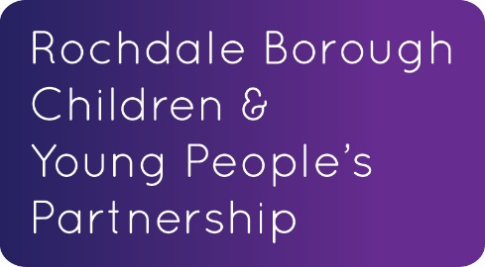

MULTI AGENCY INDUCTION BOOKLET
Rochdale Borough
Children’s Service

Supporting Integrated Working

Last Reviewed January 2020
Update Required August 2020
For further copies of this document visit
https://www.rbscp.org/professionals/children-s-workforce-strategy-induction/

Contents

- Introduction

- Shared Values, Behaviours & Responsibilities

- Information Sharing, Consent & the Seven Golden Rules for Information Sharing.

- Our Rochdale - health, social care, childcare & family information services in the borough.

- Children’s Needs & Response Framework & Step Up / Step Down Protocols

- Early Help & the Early Help Assessment, Early Years & Children’s Centres

- Safeguarding Children, Young People & Adults

- Safe Working Practices and allegations management

- Referrals to the Complex Early Help & Safeguarding Hub

- Public Law Outline & Private Fostering

- Multi-Agency Training Opportunities

- Targeted Areas of work for the Rochdale Borough

  - Assessments & the voice of the Child/Young Person
  - Relationships
  - Neglect
  - Mental health
  - School readiness
  - Obesity

- Introduction

Our services for children and young people are always changing. It is important to put children and their families at the heart of all our work. It is our ambition to make Rochdale Borough a child-friendly place, where children and young people have a real voice, with a clear set of outcomes, priorities and performance measures that will help us achieve this.

What doesn’t change is the need for all of those involved in supporting children, young people & families to work together effectively, placing the child at the centre of all we do. To make sure this happens, we need everyone to be clear about their roles and responsibilities, referral routes & to reduce bureaucracy wherever possible. We need to do the simple things well.

This Induction Booklet is a way to help everyone working with children, young people & their families to achieve consistency when working with other practitioners. It is a way to let staff working with children & families know where to go to get the correct information, guidance and support to make decisions in their work.

The Induction Booklet will be updated over time as we continue develop new ways of working locally being a starting point of shared understanding those changes as they occur.

We hope everyone who uses this Induction Booklet will find it a useful tool that helps us meet the challenge of improving the lives of children and young people in Rochdale Borough.

Councillor Kieran Heakin  Gail Hopper | Cabinet Member for Children, Schools & Families  Director of Children's Services

Useful Links:

Corporate Parenting Strategy here

Children & Young Peoples Partnership Plan 2017 – 2020 Here

- Shared Values, Behaviours & Responsibilities

In order to effectively meet the needs of children, young people & families, all practitioners should understand what is required of them, and what they are entitled to expect from the other colleagues, agencies and services that they work with. Be aware of your own service codes of conduct, values & behaviour guidelines.

Also the Children & Young Peoples Partnership have agreed that our Shared Values & Behaviours are to be;

- QUALITY DRIVEN - Be the best we can be, individually and organisationally to provide safe, evidence based services that build upon own / organisations knowledge. To be the best we can be in how we treat each other & our children, young people & their families.
- COMPASSIONATE - Act with integrity, providing services around individual needs treating everyone with empathy & act professionally at all times. Listen, be sensitive, considerate & be proactive to make sure we do not walk away or ignore concerns.
- PROACTIVE – Do the right thing & be the best you can be. Make sure children & young people receive appropriate care & support, be brave when you are not sure if others are doing the right thing, follow up & don’t stop until you are sure the right thing has been done.
- ACCOUNTABLE - For own and others actions, be honest, open and fair in all you do, taking responsibility for your own actions and the actions of others if things go wrong or are a concern.
- LEADERS -- Helping others no matter what role or position they hold. We inspire others through our actions & behaviours, setting the right example and sharing success with each other.

Our shared responsibilities;

- Support families to meet their needs & if needs cannot be met by your agency alone make appropriate assessment & referrals. Continue to support until another service/ appropriate agency accepts responsibility to provide continuity of support. (volunteers – please discuss the boundaries of your responsibility with the agency you volunteer for).

- Carry out Early Help Assessments (or other appropriate assessments) to identify the needs of families and take on the Lead Professional Role when it is in the best interest of the child / family. See Section 6 Early Help & Early Help Assessment.

- Keep good quality records of all the work you do with children, young people and families. Follow your own organisation’s policy / guidance on record keeping

- Safeguarding; We all have a duty to follow single and multi-agency safeguarding procedures if you have a concern that someone is at risk of or suffering significant harm. Ask your manager for any single agency procedures.

Useful Links;

Safeguarding Children Procedures Safeguarding Adult Procedures

3. Information Sharing, Consent & the Seven Golden Rules

Effective information-sharing underpins integrated working and is a vital element of both early intervention and safeguarding. Keeping children safe from harm requires practitioners & others to share information as it is often only when information from a number of sources has been shared & considered together, that it becomes clear that a child has suffered, or is likely to suffer, significant harm.

Practitioners should be proactive in sharing information as early as possible to help identify, assess and respond to risks or concerns about the safety and welfare of children.

Practitioners should also be alert to sharing information about any adults with whom that child has contact, which may impact on the child’s safety or welfare.
In English Law, where there are concerns that a child is, or may be, at risk of significant harm, the overriding consideration is to safeguard the child (The Children Act 1989).

The General Data Protection Regulations (GDPR) and the Data Protection Act 2018 places the need for organisations to be transparent and accountable in relation to their use of data. It does not prevent, or limit, the sharing of information for the purposes of keeping children & young people safe.

To effectively share information:

- All practitioners should be confident of the processing conditions which allow them to store, and share, the information that they need to carry out their safeguarding role. Information which is relevant to safeguarding will often be data which is considered ‘special category personal data’ meaning it is sensitive and personal;

- Where practitioners need to share special category personal data, they should be aware that the Data Protection Act 2018 includes ‘safeguarding of children and individuals at risk’ as one of conditions that allows practitioners to share information with others without consent:

  - Information can be shared legally without consent, if a practitioner is unable to, cannot be reasonably expected to gain consent from the individual, or if to gain consent could place a child at risk;

  - Relevant personal information can also be shared lawfully if it is to keep a child or individual at risk safe from neglect or physical, emotional or mental harm, or if it is protecting their physical, mental, or emotional well-being.

The Seven Golden Rules for Information Sharing

Information on children and families can be held in many different ways & may be shared face to face, over the telephone or via secure email. Whenever information is shared, a record of this should be made in the individual's record and the information should not be kept any longer than is necessary.

- Remember that the General Data Protection Regulations, Data Protection Act 2018 and human rights laws are not barriers to justified information sharing but provide a framework to ensure that personal information about living individuals is shared appropriately;

- Be open and honest with the individual (and/or their family where appropriate) from the outset about why, what, how and with whom information will, or could be shared, and seek their agreement, unless it is unsafe or inappropriate to do so;

- Seek advice from other practitioners or your information governance lead if you are in any doubt about sharing the information concerned, without disclosing the identity of the individual where possible;

- Where possible share with consent and, where possible, respect the wishes of those who do not consent to having their information shared. Under the GDPR and Data Protection Act 2018 you may share information without consent if, in your judgement, there is a lawful reason to do so, such as where safety may be at risk. You will need to base your judgment on the facts of the case. When you are sharing or requesting personal information from someone, be clear of the basis upon which you are doing so. Where you do not have consent, be mindful that an individual might not expect information to be shared;

- Consider safety and well-being: Base your information sharing decisions on considerations of the safety and wellbeing of the individual and others who may be affected by their actions;

- Necessary, proportionate, relevant, accurate, timely and secure: Ensure that the information you share is necessary for the purpose for which you are sharing it, is shared only with those people who need to have it, is accurate and up-to-date, is shared in a timely fashion, and is shared securely (Practitioners must always follow their organisation's policy on security for handling personal information);

- Keep a record of your decision and the reasons for it - whether it is to share information or not. If you decide to share, then record what you have shared, with whom and for what purpose.

Further guidance on Information Sharing, Confidentiality, Consent & Public Interest can be found in the Greater Manchester Safeguarding Children Procedures

- Our Rochdale

‘Our Rochdale’ Provides information on health, social care, childcare and family information services within the borough of Rochdale

To access Our Rochdale Click Here

This is a web based resource for parents, carers & professionals, containing contact details and information of all services available in Rochdale Borough for children and families.
It has 4 sections;
- Adult Social Care
- Children & Families
- Health & wellbeing
- Local Offer

This resource is invaluable to practitioners when they are exploring local service options to support a child and their family.
If you can't find what you are looking for and need extra guidance please contact the Family Information Service on 01706 719900 or e mail family.info@rochdale.gov.uk

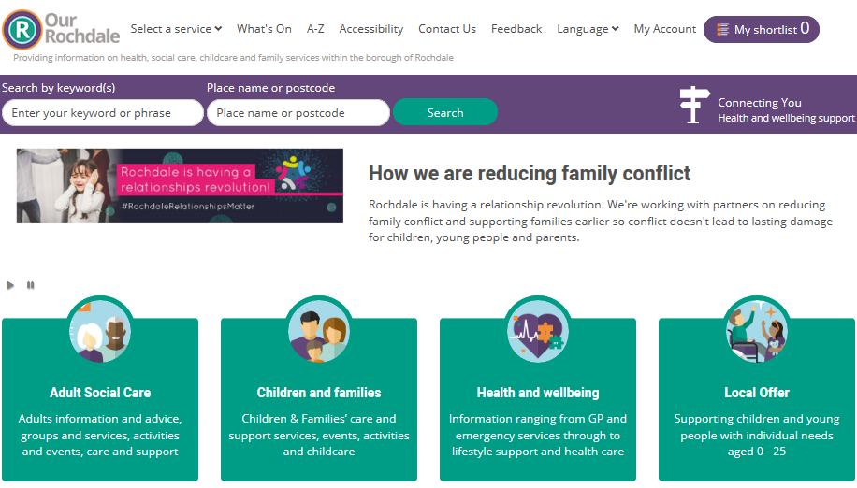

- Children’s Needs & Response Framework & Step Up Step Down protocols.

The Rochdale's Children's Needs and Response Framework applies to all children and young people from conception to the age of 18 years. It has been developed to assist practitioners and managers in assessing and identifying a child's level of need and crucially how best to respond and meet those needs as early as possible to prevent difficulties escalating into crises.
The framework reflects the continuum of need, showing that the needs of most children will be met by universal services (at level 1). However, children with additional unmet needs may require additional support (at level 2), and a small proportion of children will require acute and specialist services (at levels 3 and 4).

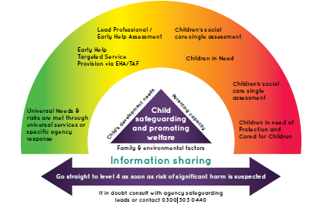

The ‘Step Up Step Down Process’ is when needs decrease in complexity or severity and a different response is required, i.e. moving from specialist to additional to universal.

There are 3 possible processes. These are;

- Cases coming down (step down) from Child in Need (level 3) to Early Help Assessment (level 2)
- Cases coming down (step down) from Child in Need (level 3) to single agency.
- Cases stepping up from Early Help Assessment (Level 2) to Child in Need (level 3) or Child Protection (level 4)
Please familiarise yourself with the most up to date version of the Children’s Needs & Response Framework Guidance, related documents & Step Up Step Down protocol
Click here

- Early Help & Early Help Assessment, Early Years & Children’s Centre’s.

Early Help is intervening early and as soon as possible to tackle emerging problems for children, young people and their families.
Early Help is effective in promoting the welfare of children and young people, it means providing support as soon as a problem emerges, at any point in a child's life, including pre-natal interventions and early years support through to the teenage years.
Early Help can prevent problems escalating to a crisis level by providing help at the right time to meet family’s needs and helps to keep them in control of resolving their issues and problems.
Useful Link: Early Help Strategy 2016 to 2019 Click Here

The Early Help Assessment
There are times when children and their families may need support from a wide range of local agencies. Where a child and family would benefit from support from more than one agency (e.g. education, health, housing, police) an Early Help Assessment will be offered to agree and coordinate that support.
The Early Help Assessment is an evidence based, family friendly tool designed to support solution focused conversations between professionals and the family. Its purpose is to identify strengths and difficulties, engage and empower individuals to achieve positive change and prevent needs escalating.
Useful Link : Early Help Assessment forms and guidance can be found Here

If you can't find what you are looking for and need extra guidance please contact the Early Help Team on 01706 925127
Early Help Assessment Tool briefings
If practitioners may be a lead professional or be asked to undertake Early help Assessments they can attend the Early help Assessment Tool briefings.
This briefing is aimed at members of the children’s workforce who work directly with children, young people and their families or those who work indirectly with children and young people (e.g. adult services who work with parents/carers), to provide practitioners from different agencies and professional backgrounds an over view of the Common Assessment Framework, the role of Lead Professional and Team Around the Child Meetings.
More information & how to book on an Early help Assessment course can be found here

Early Years & Children’s Centres

The Early Years Advisory Team
The Early Years Advisory team is made up of teachers and advisors who support private and voluntary settings and childminders across Rochdale.
They offer a range of services, including training of Early Years staff, bespoke packages to help improve a setting or childminder’s Ofsted grade following the receipt of an inadequate or requires improvement inspection result and they also offer pre-inspection checks to help to identify any actions that should be addressed, before Ofsted come out and to reassure providers that they are prepared.
The Early Years Advisory team also offer training and support to improve EYFS attainment by the end of reception and are trained as ELKLAN trainers to improve children’s speech and language across the borough.

The Sufficiency and Training Team
The Sufficiency and Training Team ensure that demand and supply of places are met as much as possible across Rochdale.
They raise the profile of funded places and arrange the payment to all providers for the funded places that are used.
They ensure that settings are able to access a wide variety of training over the course of the year and organise the venues, trainers, invoices and any additional requirements.

Family Learning Service
The aim of the Family Learning Service is to enable parents of 0-11 year olds to be as involved as possible in their children’s education, so that they can help them reach their full potential.
They deliver short courses that involve parents/carers and their children working together to improve various skills and levels of development.

Children’s Centres
The main aim of Children’s Centres is to improve outcomes for all young children, so that they are happy, healthy and ready for school. We want to provide help and support to young children and families as soon as there is a need, helping to prevent any problems developing.
The facilities and activities provided are designed especially for parents expecting a baby or those with a child under five years old.
Children’s Centres embrace a multi-agency approach and are effective at partnership working in order to do this well. They work closely with midwives and health visitors, working towards public health outcomes, provide adult education and parenting programmes, ensure that the sessions for children focus on a wide range of learning opportunities across all seven areas of learning and also offer supporting family keyworker services.

- Safeguarding children, young people & adults.

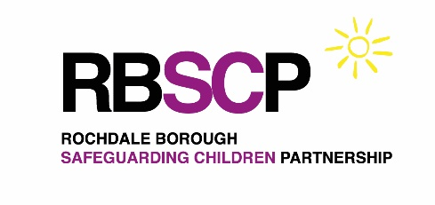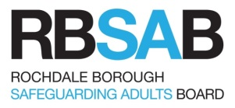

All practitioners and volunteers have a responsibility to safeguarding children young people and adults if they are at risk of significant harm. Your manager will inform you of your single agency safeguarding procedures.

The Rochdale Borough Safeguarding Children Partnership & Adults Board oversee the multi-agency safeguarding of children and adults in the borough, including oversight of development & quality assurance work.

To ensure a consistent approach to safeguarding across the borough, there are also multi-agency procedures to follow if you have safeguarding concerns about a child or adult. You can find the links below:

Safeguarding Children Procedures Safeguarding Adult Procedures

Learning Lessons from cases
Rochdale Borough Safeguarding Children Partnership & Adults Board are responsible for conducting Child Safeguarding Practice Reviews & Serious Adult Reviews. These reviews play a vital role in helping practitioners and organisations to continually improve the way they work, individually or together, to keep children, young people and adults safe and free from harm. It is important that all practitioners keep up to date with the lessons learned that inform positive practice. This can be done by reading the full reports , attending multi-agency briefings on lessons learned and reading the Good Practice tools (7 minute briefings/Tips for practitioners) - all available on the RBSCB/RBSAB websites.
Safeguarding training

Safeguarding training should be provided by your service and updated every three years. Your manager should let you know where this can be accessed within your service.
Those who work regularly with children & young people and those that have specific safeguarding responsibilities may also need to access specific multi agency training delivered by the Rochdale Borough Safeguarding Partnership / Board – the suite of training can be found Here

Guidance on training levels for safeguarding can be found here; Here

Useful Links;

Child Safeguarding Practice Reviews Adults Safeguarding Reviews

Children’s 7 Minute briefings Adult 7 Minute briefings

8. Safe Working Practices & Allegations Management

Staff and volunteers should work within safe boundaries when working with children young people & their families. Your manager should inform you of the single agency safe working guidance & procedures to follow in your service and any training available on Safe Working Practices.

There is also multi agency guidance on safe working practices available Here.

If there is an allegation against a member of staff working with children & young people your manager will follow the allegations management procedures.

In the first instance information should be shared with the senior nominated officer within the organisation. The senior nominated officer then may liaise with the LADO (Local Authority Designated Officer) who provides management & oversight of individual cases of allegations of abuse made against those who work with children.

The threshold for referral under allegations management is a person in regulated activity with children who has:
- behaved in a way that has harmed, or may have harmed, a child.

- committed a criminal offence against, or related to, a child.

- behaved towards a child or children in a way that indicates they pose a risk of harm to children.

The LADO’s role is to give advice and guidance to employers and voluntary organisations; liaise with the Police and other agencies, and monitor the progress of cases to ensure that they are dealt with as quickly as possible consistent with a thorough and fair process.
There is further information available on allegations management Here
There is multi agency guidance the role of the Allegations Management lead for adults & managing allegations against staff & volunteers working with adults with care and support needs too Here

If you have a concern about a person who works with children & young people speak to your Senior Nominated Officer who can e mail lado@rochdale.gov.uk for advice.
If you have a concern about a person who works with vulnerable adults speak to your senior nominated officer who can e mail Jayne.todd@rochdale.gov.uk for advice.

9. Referrals to the Complex Early Help & Safeguarding Hub

The Complex Early Help & Safeguarding Hub will support professionals who are leading on Early Help Assessments & Team Around the Family meetings for families who have continuing or escalating concerns about risks to a child / children. The hub will refer through to social care if there is evidence that the team now requires a social care lead.
Concerns for the welfare of children, young people and families can also be reported to the complex early help and safeguarding hub by members of the public by telephone.
This Complex Early Help & Safeguarding Hub is also the referral point for Children’s Social Care where there is an immediate risk of significant harm to a child/children.
The Complex Early Help & Safeguarding Hub team is made up of a variety of services including the Police, Children’s Social Care, Early Help and Health, all of whom contribute to contribute to the decision making regarding individual cases.
Who to contact
Telephone 0300 303 0440 (8.30am - 4.45pm)
0300 303 8875 (Out of office hours)
E-mail ehash@rochdale.gov.uk

If you have a concern that a child or young person you are working with is suffering or at risk of suffering significant harm, you must:

- Discuss your concerns with your line manager and/or lead officer for safeguarding
- Seek consent from the parents / family (unless to do so would place the child at greater or immediate risk). Failure to obtain consent must not stop a request for service being made
- Make a referral or consult with the Complex Early Help & Safeguarding Hub
0300 303 0440
The Multi Agency procedures & Referral Form can be found Here referrals should include any historical support information (such as an Early Help Assessment) where appropriate.
- If your concern is during the evening or weekend you can contact the Emergency Duty Team – contacts below.

Emergency Duty Team
(Out of Hours - 5pm - 8am & weekends)
0300 303 8875

Police
101 / 999 if there is an immediate risk to a child

IMPORTANT - Never delay emergency action to protect a child or young person from harm.

Further guidance can be found on the GM Multi Agency Safeguarding Children procedures Click here
It is important that staff are trained to an appropriate safeguarding level – find more guidance in this booklet in Section 12. Multi Agency Training Opportunities.

10. Public Law Outline & Private Fostering;
The Public Law Outline* sets out case management procedures for dealing with public law children's cases. The aim is to identify and focus on the key issues for the child, to help make the best decisions for the child within the timetable set by the Court, avoiding the need for unnecessary evidence or hearings.
As well as the Court-set timetable, the case management tools also involve the case management documentation to be filed by the local authority and other parties, (including case summaries and a schedule of proposed findings), advocates' discussions/meetings, a Case Management Hearing and an issues resolution hearing before the final hearing.
The aim is to complete cases within 26 weeks.
The reduced 26 week timescale means that we need robust assessments at the earliest opportunity to avoid delay in plans of permanence. Click here to see policy

Private Fostering
A private fostering arrangement is one where children under the age of 16, or 18 in the case of disabled children, are cared for and provided with accommodation in the carer's own home, by a carer who is not their parent or a close relative, does not have parental responsibility for a period of 28 days or more. In these circumstances, it's the responsibility of the parent, carer, and anyone else involved in making the private fostering arrangement, to notify Children’s Social Care of the private fostering arrangement.
Privately fostered children include:
- Children sent from abroad to stay with another family for 28 days or more.
- Asylum seeking and refugee children staying with non-relatives or friends for 28 days or more.
- Teenagers who are staying with friends or 'non' relatives for 28 days or more.
- Children on 'exchange' visits living with host families for 28 days or more.

Professionals working with children & their families have a responsibility to notify the local children’s services department of any private fostering arrangements. It is only by working together that all agencies can make sure that all privately fostered children get the quality of care they deserve.

Private foster carers may be from the extended family if they fall outside of this definition, such as cousin or great aunt/uncle.

The definition will only apply if the arrangement is intended to last for at least 28 days, or has already exceeded this length of time.

A child who is Looked After or placed in any residential home, hospital or residential school is excluded from the definition. In a private fostering arrangement, the parent retains Parental Responsibility.

For more information on Private Fostering & useful posters for professionals and children / young people Click here

11. Multi-Agency Training Opportunities

Safeguarding training

Basic Safeguarding training should be provided by your service and updated every three years. Your manager should let you know where this can be accessed within your service.

Those who work regularly with children & young people and those that have specific safeguarding responsibilities may also need to access specific multi agency training delivered by the Rochdale Borough Safeguarding Partnership – the suite of training can be found Here

Guidance on training levels for safeguarding can be found Here

Early Help Assessment Tool briefings
If practitioners may be a lead professional or be asked to undertake Early help Assessments they can attend the Early help Assessment Tool briefings.
This briefing is aimed at members of the children’s workforce who work directly with children, young people and their families or those who work indirectly with children and young people (e.g. adult services who work with parents/carers), to provide practitioners from different agencies and professional backgrounds an over view of the Common Assessment Framework, the role of Lead Professional and Team Around the Child Meetings.
More information & how to book on a course can be found here

Integrated Children’s Workforce Multi-Agency Welcome Event

This annual event provides new workers & staff who have moved within the borough with an insight into the work of the Children and Young People’s Partnership and the local approach to integrated multi- agency working. It also provides information on local services and the development opportunities available in the Borough.
If you have enquiries about the next event e mail; learning@rochdale.gov.uk

Personal Development plans
Your agency should provide you with a continuing professional development plan. The Children & Young Peoples Partnership recommend that these plans consider a range of learning opportunities such as E learning, face to face training & coaching / mentoring).
The Children & Young Peoples partnership have also identified the following areas as a minimum development list for agencies to consider during their CPD support of their staff.
- Communication & Engagement
- Think Family
- Child development
- Safeguarding & welfare of children young people & adults.
- Supporting transitions
- Multi agency integrated working
- Information sharing
12. Targeted Areas of work for the Rochdale Borough

- Assessments & the voice of the Child/Young Person

Assessments
It is vital when working with children, young people & their families that we begin to identify & assess specific needs at the earliest opportunity – all practitioners should be supported by their services to understand & use assessment tools.

There is a list of agreed multi agency assessment tools on the Rochdale Borough Safeguarding Children Partnership

The Voice of the Child/Young Person

In a good practice assessment we should reflect on the lived life experience of the child/young person. Their views experiences & wishes should be sought in a structured manner which can then reflect their voice within assessments, planning & direct work.
Good practice also requires us to communicate effectively with children & young people.
Rochdale Borough Safeguarding Children Partnership has a list available resources to help us capture the voice of the child Here

Rochdale Borough Council Children’s Services Staff can also access the Strengthening Practice Tools for Assessment & obtaining the Child’s Voice Tools HERE
(NB this is an internal council staff web address only)

- Relationships & Domestic Abuse

All partners in Rochdale are working together to reduce family conflict and support families earlier so conflict doesn't lead to lasting damage for children, young people and parents Read more about it Here
Read the Relationship Manifesto for Rochdale borough

Domestic Abuse
In our Borough, all local agencies have a vital part to play in supporting victims, bringing perpetrators to account and raising awareness. Many of these agencies are already undertaking significant and valuable work to promote safety and provide effective interventions.
Read the Domestic Abuse Strategy
Find supportive Domestic abuse checklists, assessments and resources HERE

- Neglect

The Rochdale Borough has a Neglect Strategy. We also have a Neglect Screening Tool, Graded Care Profiles (0-12 & adolescents) in order to assess & identify issues at the earliest opportunity and other useful resources. All of the above can be found HERE

- Mental health
Looking after our health and wellbeing is important, it determines how we feel about ourselves and influences everything that we do. Practitioners can find contact details for Adult Social care, information on mental health, wellbeing & mental health therapies HERE

- School readiness

It is important to support the children in the rochdale borough to be ready for school Find out about Supporting Children in Rochdale to be ready for school by clicking the link.

- Obesity

In Rochdale 68.8% of adults are classified as having excess weight, which is above the England rate of 61% .
Find out about the Joint Strategic Needs Assessment (JSNA) which identified key issues affecting the health and wellbeing of our Rochdale Borough residents, both now and in the future HERE .

If you have any comments/ amendment requirements regarding this induction booklet please e mail learning@rochdale.gov.uk

