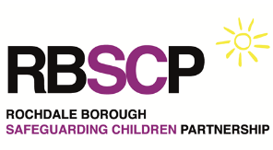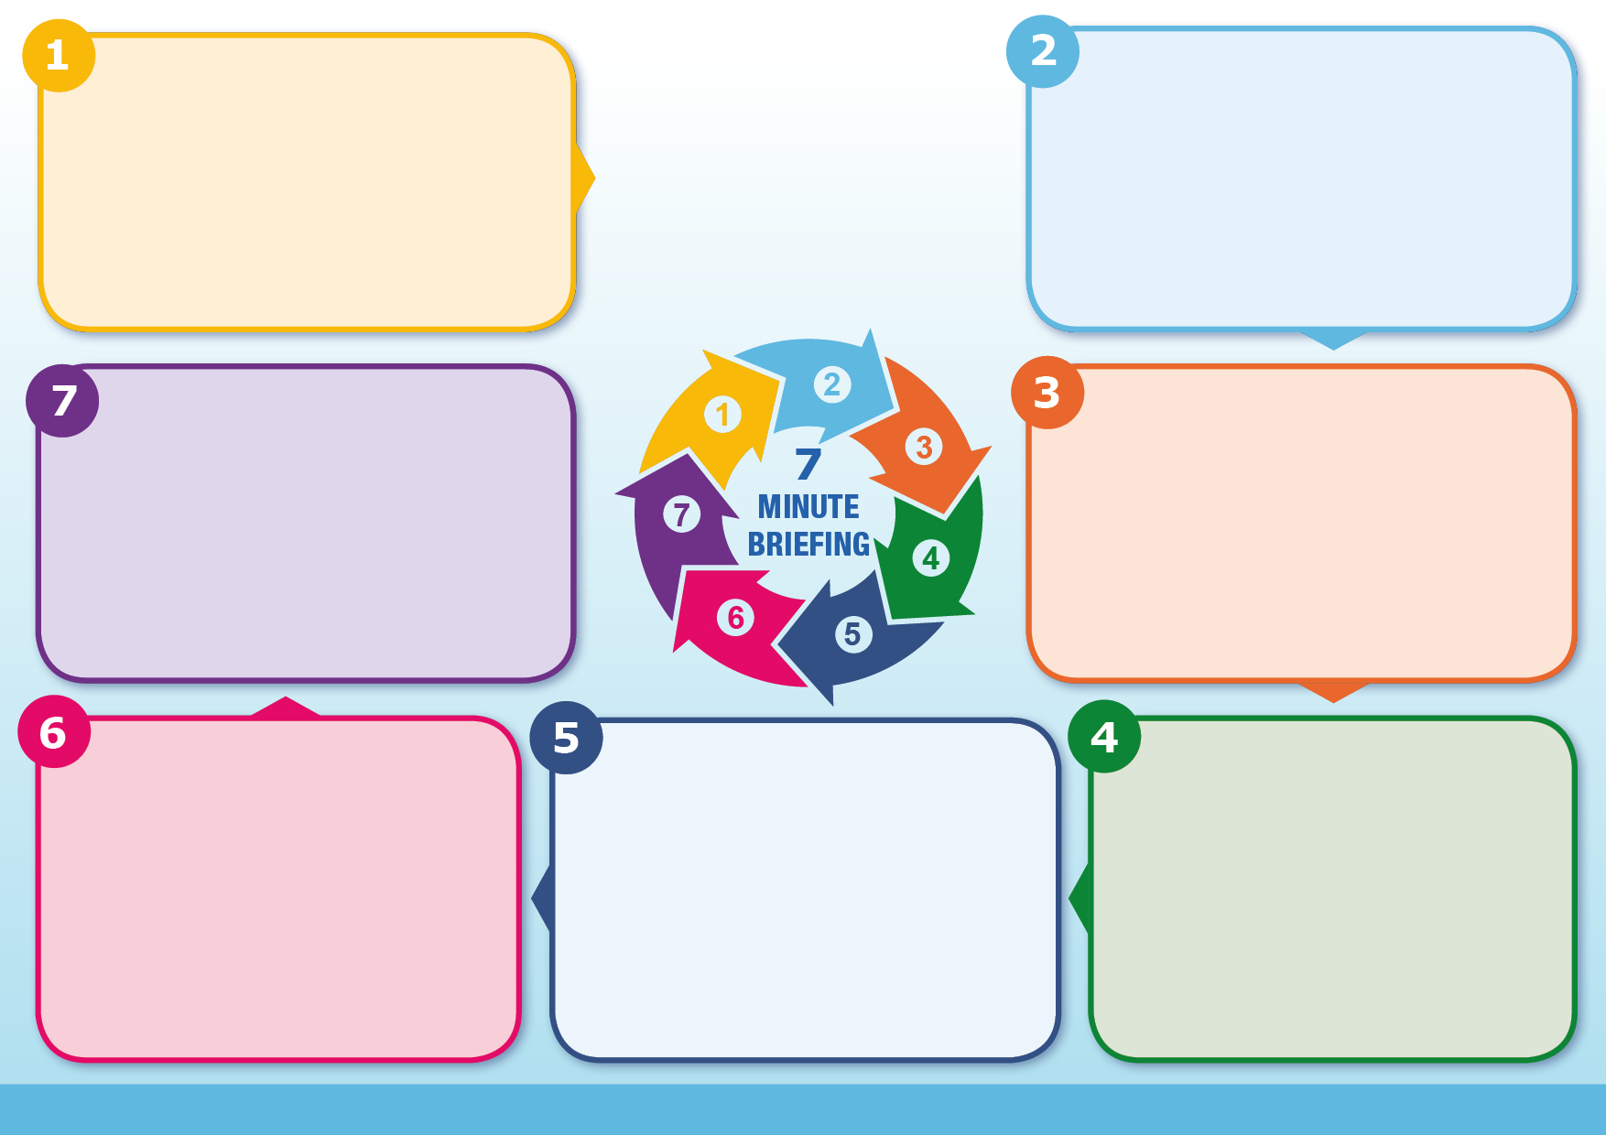

Partnership working is essential in effectively tackling cuckooing and to prevent reoccurrence. It’s important to identify it as early as possible and ensure the nature of the ‘victim’ is recognised. If you are worried that an adult is a victim of cuckooing, you should contact the police via 999 if there is an immediate risk of harm, or for non-urgent cases via 101 or the Greater Manchester Police ‘[Report a Crime’](https://www.gmp.police.uk/ro/report/ocr/af/how-to-report-a-crime/) webpage.

You can also make a safeguarding referral. See these pages to report [adult safeguarding](https://rochdalesafeguarding.com/rbsp/p/how-do-i-report-a-concern-about-adult-abuse-or-neglect) or [children’s safeguarding](https://rochdalesafeguarding.com/rbsp/p/how-do-i-report-a-concern-about-a-child) concerns.

NOTE: the government has published the [Crime and Policing Bill](https://www.gov.uk/government/news/child-criminal-exploitation-and-cuckooing-to-be-criminal-offences) which will make cuckooing a specific offence.

* More information can be found via: [Programme Challenger](https://www.programmechallenger.co.uk/practitioner/resources/cuckooing/), [British Red Cross (North West),](https://www.redcross.org.uk/about-us/what-we%20do/modern-slavery-and-trafficking) [Stop the Traffik](https://stopthetraffik.org/), [the Salvation Army](https://www.salvationarmy.org.uk/modern-slavery) and the [Modern Slavery Helpline](https://www.modernslaveryhelpline.org/): 08000 121 700.
* [Leeds University Preventing and Disrupting Cuckooing Victimisation: Professional Toolkit](https://essl.leeds.ac.uk/downloads/download/250/preventing-and-disrupting-cuckooing-victimisation-professional-toolkit)
* [See No Evil](https://vimeo.com/384838555) video
* It is also important to involve the housing provider if this is a registered housing provider or the landlord if it is a privately rented property.
* To refer concerns or ask advice / discuss your concerns in Rochdale - email [pet@rochdale.gov.uk](mailto:pet@rochdale.gov.uk)

Cuckooing refers to the practice whereby criminals take over a person’s dwelling (often the home of a vulnerable person, such as an individual living with substance addition or physical or mental disabilities) to use it for illegal activities and is often associated with anti-social behaviour and the exploitation of children by criminal gangs. Criminals often befriend a vulnerable person in order to exploit them and use their property. The term takes its name from cuckoos who take over the nests of other birds. Initially perpetrators may approach the vulnerable person offering free drugs or other things they may need; however, this may progress to threats of violence, and/or the victim being made to pay off drug debts through use of their home and/or to assist in drug dealing.

The criminals use the property to provide a discreet location out of sight of police from which to conduct their activity. They will use a range of tactics to control the victim. This could be pacifying victims using drugs. Once the ‘high’ wears off the victims want the criminals to leave, leading to threats or violence being used.

Cuckooing does not always involve drug dealers/ organised crime. There are other types – such as other homeless/drugs users moving themselves in, e.g. starts as a reciprocal renting arrangement and then the control begins and the tenant can’t ask the person to leave. This can often lead to others moving in too.

**Further information**

**Making a referral**

May decreased their engagement with services

• May have unexplained injuries

• Has paid off debts in full with cash

• May be misusing substances

• May be carrying weapons

• Appears withdrawn and fearful of disclosing information

• Has changed appearance, either wearing expensive clothing or appearing unkempt

• May be scared or not willing to disclose what’s happening or leave the property

**Spotting the Signs – the vulnerable person**

High number of vehicles stopping at the property for a short time

• Increased complaints of noise

• Young people frequenting the property

• Increased anti-social behaviour and crime around the property

• Open drug dealing near the property

• The resident of the property not being seen as often as they previously were

• People coming and going at various times day and night

• Curtains and blinds being closed at the property

• Damage to property or open doors

• Security safe in the property

**Spotting the Signs – the property**

**Controlling the victim**

Victims are vulnerable individuals and include people who are:

• Living with drug or alcohol addiction

• Older

• Living in a ground floor flat or close to a stairwell

• Living with mental or physical health conditions

• Living with learning disability

• Experiencing poverty, drug debt or financial difficulties

• Isolated

• Having reduced contact with services

• Single parents

• Involved in prostitution

**Who are the victims?**

**What is Cuckooing?**

**Cuckooing/ Home Invasion**