

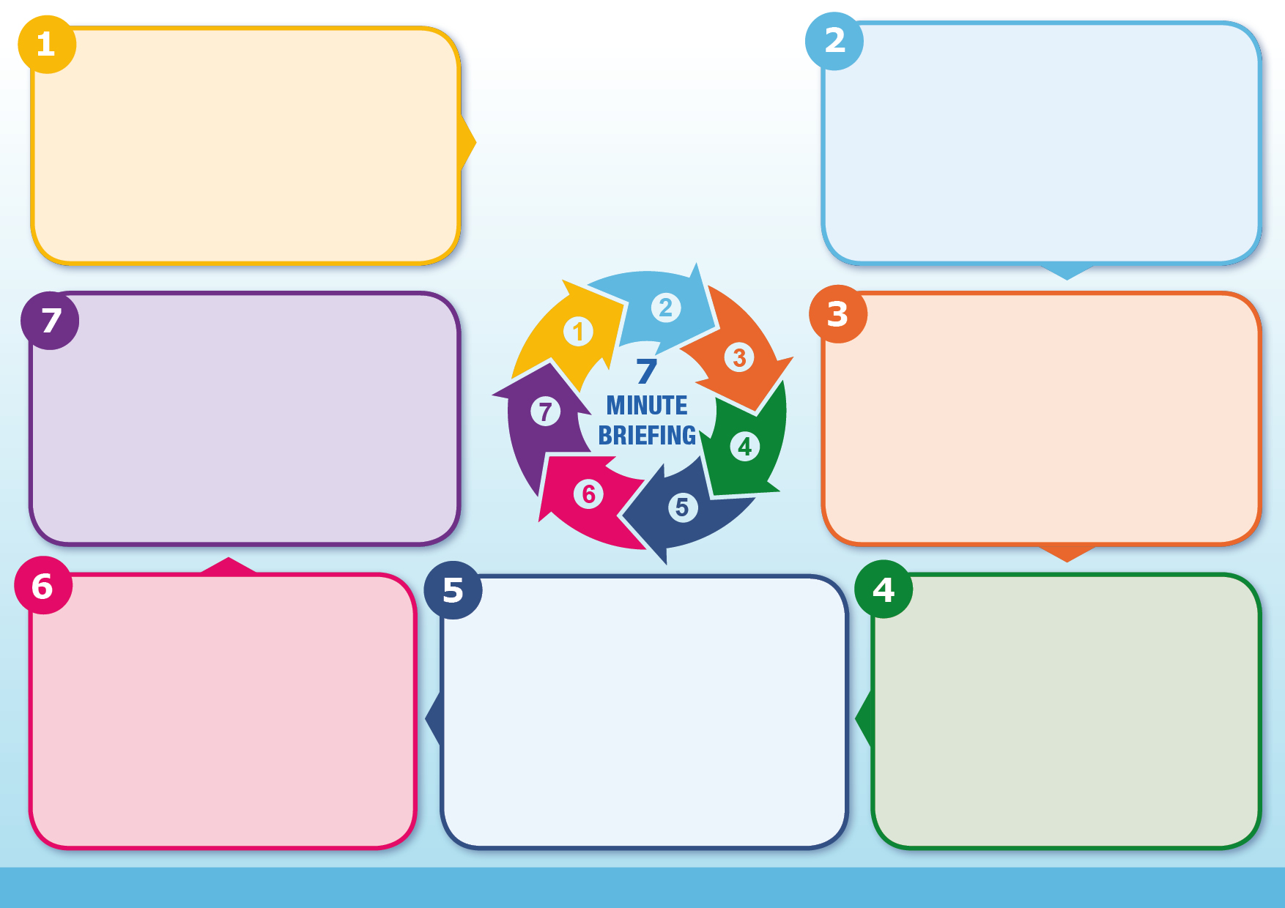
What is the assessment for?
What is the story / history
What does the story mean?
How does this affect them.?
What needs to happen?
What does the person want?
How do we know we are making progress?
Questions
Developing the habits required to support critical thinking takes conscious effort. Treat your first reaction to a situation, issue, or person as temporary. Resist the urge to pass judgement based only upon initial reactions. Have you observed carefully?
Examine your reaction(s). Try to understand why you reacted the way you did. What assumptions were you making? What previous experiences may have contributed to your reaction? Think of alternative responses to situation, or issue at hand. Try to put yourself in someone else’s shoes (e.g. child/young person \ adult at risk).

What to do?
Feeling under pressure to make quick decisions even when information is limited; people’s emotions interfering capacity to listen to others; feelings of ambivalence or even fear about seeing a particular family; or being overly optimistic about parental capacity for change.
It is important that practitioners are willing and able to recognize that a previous decision may have been wrong – though reasonable at the time when the decision was made. Consensus isn't always safe. The fact that everyone agrees does not mean that they are right - and certainly does not keep a child or adult at risk safe. There is no safety in numbers - risk does not decrease because more people agree. Minority views are important and must be considered and noted within multi-agency work. Consider what it is about that worker's experience that differs from others’
Information
Obstacles to Critical Thinking
Information
Critical thinkers are:
- Open to new information and will seek and consider alternative hypothesis
- Aware that stress and the opinions of others can distort thinking
- Able to consider information from multiple sources, even those that have opposing views
- Self-aware, self-reflective, active listeners, and empathetic
- Able to recognize faulty reasoning and logic
- Able to conduct analysis, draw accurate conclusions, and articulate thoughts
Why it matters
Critical thinking is purposeful. It involves maintaining an open minded attitude & being able to think about different ways of understanding the information before you. Critical thinking also includes a process of evaluating claims & arguments in order to come to logical & consistent conclusions, assessing these conclusions against clear & relevant criteria or standards, & being able to spell out the reasons for the judgements you have made.’ (Turney 2014)
Background
Critical Thinking
Core skills such as professional curiosity, professional judgement, the ability to conduct rigorous assessments and draw conclusions are vital to safe planning. Practitioners must have an understanding of the blocks & challenges in safeguarding work and apply strategies to manage these, including situations of hostility & disguised compliance & to challenge their own and others’ practice both at individual and agency level.

