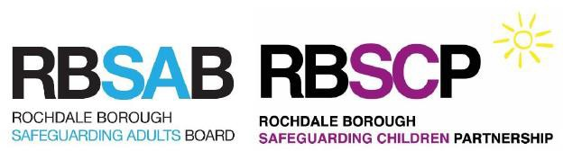

**The Health of Children with Parents Related by Blood**

This leaflet explains the issues around cousin marriage and the health of their children and gives details of support services available.

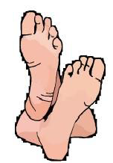

## The effect of genes

Blood relatives look alike because they share some of the same genes. Genes are the biological codes that decide a person’s characteristics and also any other factors that may be inherited. If a mother or father has large feet or blue, brown or green eyes this may be inherited by their baby.

Our genes are inherited from our parents. We may also inherit disorders which are passed on through ‘changed’ genes. These type of disorders are called ‘genetic disorders’. These genetic

disorders may be responsible for babies and children either having a long term disability or even dying because of the disorder. There are many different types of genetic disorders, for example sickle cell anaemia, thalassaemia and cystic fibrosis.

Any family, from any community, can be affected by genetic disorders. However, where partners are blood relatives, such as cousins (consanguineous) some genetic disorders - known as ‘recessive’ disorders - are more likely to occur.

Although most babies born to partners who are cousins are healthy, when both parents have a ‘changed’ gene it can cause a child to be born with a recessive disorder.

# How recessive disorders are inherited

Everyone inherits a gene from each parent for every inherited characteristic, e.g. one gene for eye colour from the mother and one from the father. The diagram shows a healthy couple, they both carry a normal gene and a changed gene, they are healthy carriers. When both parents carry a changed gene for the same characteristic there is a chance that a child could inherit a genetic disorder. The parents don’t have the genetic disorder because one of the genes for this characteristic is a normal gene.

## Healthy carrier Healthy carrier

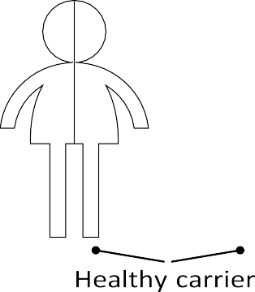

 

Because a child inherits one gene from each parent there are three possible outcomes for every child born.

1. One in four children born can inherit a normal gene from both parents, in this case the child would not have or carry the changed gene/disorder;
2. Two in four children would inherit a normal gene and a changed gene, in this case they would be carriers of the changed gene/disorder, ie a healthy carrier.
3. There is also a one in four chance that a child born to parents, both carrying a changed gene, would inherit the disorder.

These outcomes are the same, every time healthy carrier couples have a child.

# Cousin marriages and genetics

Blood related couples have a greater chance of having a child with an inherited disorder because genes get passed on in families, therefore if a brother and sister are both carriers of a changed gene, their children may also be carriers of the changed gene. If their children, who would be cousins, marry, they would have the same possibilities of having a child with an inherited (recessive) disorder.

Research has shown that for every 100 babies born to unrelated couples, fewer than three babies will have an inherited disorder but for every 100 babies born to blood related couples five to six babies will be born with inherited disorders.

# Your questions answered

## Do genetic disorders only affect certain heritage communities?

No. Genetic disorders are found in every community but because cousin marriage is common in Asian and Arab communities, marriages between cousins produce a higher rate of children born with recessive disorders.

## Does marrying your cousin mean you will have disabled children?

Marrying your cousin doesn’t necessarily mean that you will have disabled children but if you both carry a recessive gene then the chance of having a child with a recessive disorder is greater, a one in four chance each time.

When cousins who marry have a healthy child, this could be because the child inherited a healthy gene from each healthy carrier parent or because both parents do not carry the same recessive gene.

## Why is this information relevant to cousins who are already married?

Knowing the risks means that, should you wish to, you are able to prevent a child being born with a recessive disorder or dying prematurely.

# Where can I find more information?

If you are married to your cousin or are thinking of marrying your cousin or just want to know more, maybe because there is a genetic disorder within your family and you want to know about the risks to your children, speak to your family doctor. You may want to take this leaflet with your to help the conversation.

Your doctor may decide to send you to a local Genetics Service. Genetics Services provide specialist counselling and advice. Some Genetics Services can arrange tests which will identify some recessive disorders, not all disorders are yet able to be screened but new tests are being developed all the time.

# Other sources of information:

UK Genetic Alliance [www.geneticalliance.org.uk](http://www.geneticalliance.org.uk/) UK Thalassaemia Society [www.ukts.org](http://www.ukts.org/)

UK Sickle cell society [www.sicklecellsociety.org](http://www.sicklecellsociety.org/)

[Links found between ‘honour’ based violence and cousin marriages – IKWRO - End The Fear](https://www.endthefear.co.uk/2015/09/09/links-found-between-honour-based-violence-and-cousin-marriages-ikwro/)

[Honour Crimes and Cousin Marriages with Joanne Payton - YouTube](https://www.youtube.com/watch?v=6fKqOxSF8MA)

[My Cousin, My Husband by Germaine Tillion | Waterstones](https://www.waterstones.com/book/my-cousin-my-husband/germaine-tillion/9780863566257)

This Factsheet is based on an original produced by Cambridgeshire and Peterborough CDOP and Safeguarding Children Board, and is reproduced with their kind permission.