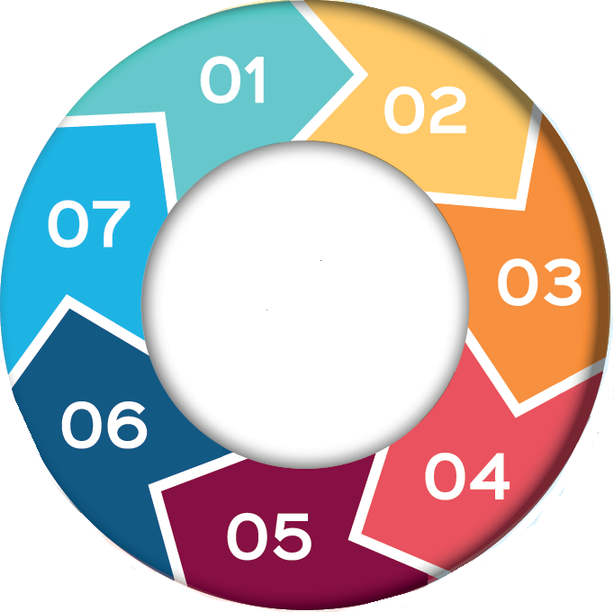

**What can happen in a closed culture?**

• The care given takes little account of the individual’s needs and personality

• Less focus on making sure people can see their family and have privacy

• Health conditions may not be recognised because the person’s behaviour is thought to be because of their dementia or learning disability

• Decisions are made without appropriate use of the Mental Capacity Act

• People’s personal distress is not considered e.g. past trauma

• Care may be arranged that leads to disproportionate and

unnecessary infringements on the person’s liberty

**Signs of a ‘closed culture’ (CQC 2022)**

* Staff not understanding or speaking warmly about the people they are caring for.
* Staff belittling, excluding or taunting people.
* Care plans not being individualised or reflecting the person's voice.
* A lack of reasonable adjustments
* Poor or absent communication plans for people who have communication needs and or communication plans not being followed.
* Restrictions, including restraint, long-term segregation and prolonged seclusion, being imposed on people without an assessment of need, legal authority/legitimate aim or that have been imposed legitimately but are not subject to review and or do not ease over time.

**Signs of a ‘closed culture’ continued (CQC 2022)**

* Blanket restrictions are in place and are not necessarily the least restrictive option.
* People being asked to go to their rooms or another area and prevented from leaving.
* Poor application or understanding of the Mental Capacity Act (MCA) and Mental Health Act (MHA), including not following the MCA, DoLS and MHA Codes of Practice.
* Concerns about medicine management including inappropriate use of medicines to restrain or control behaviour.
* People are not safeguarded against discrimination, harm and abuse.

**If you have concerns relating to organisational or closed culture abuse, further support can be sought from the PIPOT or LADO, details can be found on each local authority website.**

**Encouraging Best Practice**

• Identify and promote each individual’s human rights,

wishes and desires in line with the Mental Capacity Act.

• Work with families as equal partners to ensure their voice is heard

• Consider least restrictive practice- Mental Capacity Act.

• Promote Professional Curiosity among staff.

• Understand, hear from, and ‘see’ adults & children who are placed in care settings or who are isolated.

• Encourage and support a transparent culture.

• Ensure your organisation has a whistle blowing procedure.

• Discuss with staff; use team meetings, supervision, and mentoring, etc.

• Make sure staff have an induction upon employment and adequate training for their role.

• Senior leaders have a role in setting the tone and acting as a role model to staff.

Closed cultures are more likely to develop in services where:

* people are removed from their communities
* people stay for months or years at a time
* there is weak leadership
* staff lack the right skills, training or experience to support people
* there is a lack of positive and open engagement between staff and with people using services and their families
* In these services, people are often not able to speak up for themselves - this could be through lack of communication skills, lack of support to speak up or abuse of their rights to speak up.

**Closed**

**Culture & Organisational**

**Abuse**

Closed cultures in health and social care can increase the risk of harm to people in a care service, due to deliberate or unintentional abuse, negligence and breaches of human rights. Whether it was an accident or on purpose, a closed culture often results in unacceptable harm being bestowed on individuals.

Any service that delivers care can have a closed culture, both for adults and children.

The Care Quality Commission (CQC) has published guidance to enable staff to recognise a closed culture and to flag the warning signs that there is the risk of a closed culture developing.

It highlights the need for professional curiosity, and being better at understanding, hearing from and ‘seeing’ adults who are placed in high-risk settings or who are isolated.

**Organisational & closed culture abuse**

Organisational abuse is where poor working practices and inadequate care in a specific setting leads to the mistreatment and/or harm of adults and children at risk.

Organisational abuse doesn’t have to involve physical violence. It can be something as small as insisting that a person in care must drink their tea at the same time every day. This is the sort of thing that many of us take for granted. But when the right to choose is taken away, it can count as abuse.

The abuse can either be a one-off incident or an ongoing culture of ill-treatment and can take many forms, including neglect, and poor professional practices as a result of the structure, policies, processes and practices in an organisation. The Ann Craft Trust 2024

**Background**

Cannabis is a hallucinogenic drug. It is also known as weed, hash, marijuana and pot. Cannabis can be taken in a variety of ways; smoked mixed with tobacco in a cigarette or bong, mixing into edibles such as cake or sweets or vaped.

The strength of cannabis on the market has increased significantly over the past 20 years**.**

The effects of cannabis can vary widely, some people feel relaxed, happy and giggly, others feel paranoid, anxious or confused.

abis on the market has increased significantly over the past 20 years**.**

The effects of cannabis can vary widely, some people feel relaxed, happy and giggly, others feel paranoid, anxious or confused.

abis on the market has increased significantly over the past 20 years**.**

The effects of cannabis can vary widely, some people feel relaxed, happy and giggly, others feel paranoid, anxious or confused.

Howew