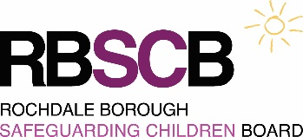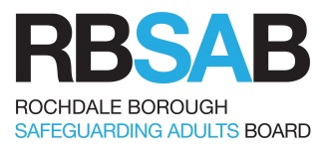

**Rochdale Borough Safeguarding Boards**

**Training Charging Policy**

**Charging for training places**

All training provided by the Rochdale Borough Safeguarding Boards is free of charge. However, Academies who do not contribute to the Safeguarding Boards’ budget will incur the following charges:

* £100 per delegate half day course
* £200 per delegate full day course

Payment will be requested after the event. An invoice address will be required at the booking stage.

**Non-attendance charges**

The Boards appreciate that at times agencies may need to cancel places reserved on training courses. However this can be costly in terms of wasted resources. The Boards therefore expect applicants to observe the following procedure:

* In cases when an applicant cannot attend, the service should endeavour to find a replacement attendee.
* If no replacement is available, all cancellations from training courses should be made at least five working days in advance of the course date.

All organisations will be charged for cancellations made less than five working days prior to the course and for non-attendance on the day of the training. The rate will be:

* £25 for one hour briefings
* £50 for half day courses
* £100 for full day courses

Exemptions to this charge will only be made in the case of:

* Inspection where the member of staff is expected to participate where the notice period was less than 7 working days.
* Unexpected operational issue for emergency service staff such as police, fire or ambulance service.

In all such cases the reason must be verified by the line manager in writing. Managers will be informed by email of any charges incurred for late cancellation/non-attendance.

An appeals form is available should the service wish to a challenge the charge.

**Note:** Charges apply both for face-to face training and virtual (on-line) training.