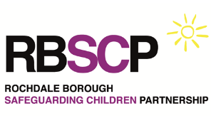
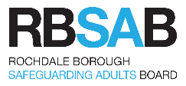
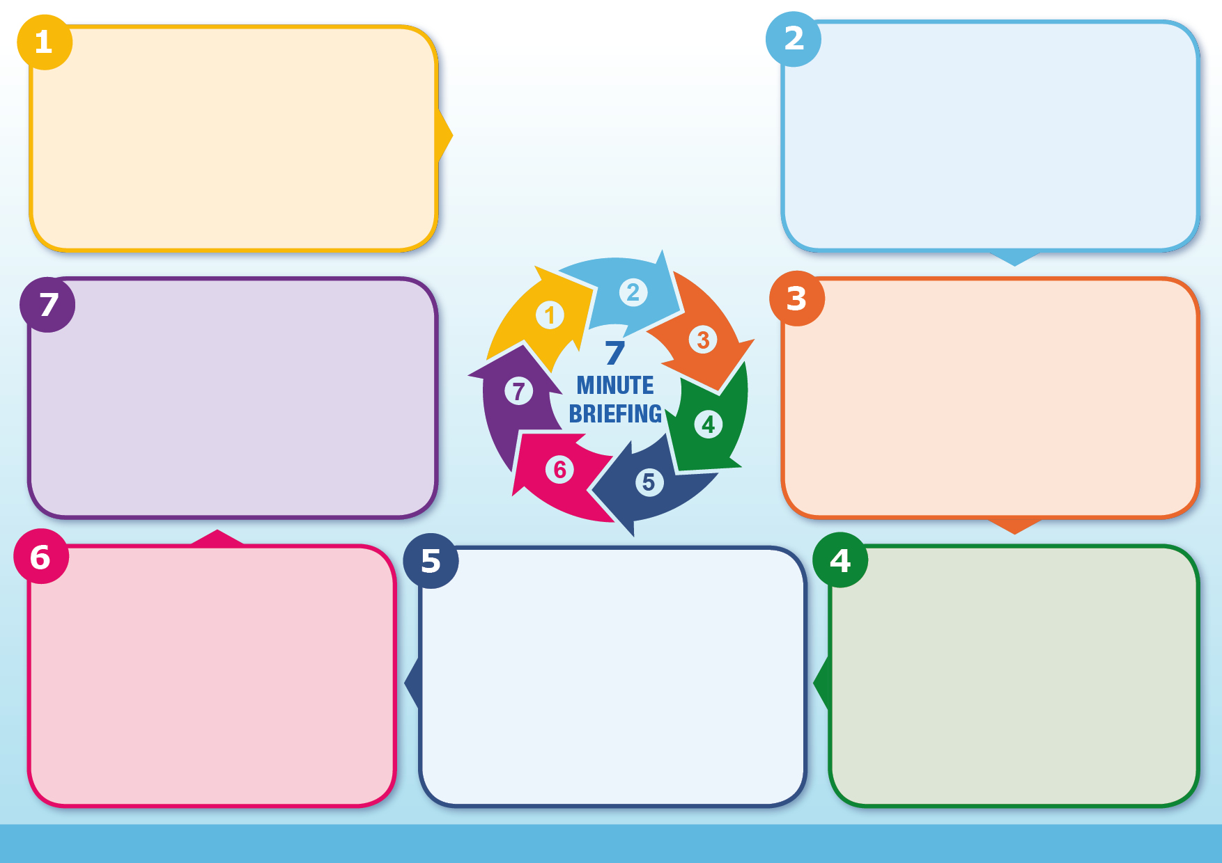
Abusive Head Trauma (AHT)
If you feel a child is in immediate danger, please call 999 for an ambulance and report to the police
You can call EHASH on 0300 303 0440 to speak to someone in Rochdale’s Children’s Social Care about your concerns inside working hours or the emergency duty team (EDT) on 0300 303 8875
Concerns about upsetting parents should never prevent practitioners from discussing the risks of Abusive Head Trauma (AHT). Evidence shows most parents welcome clear, supportive education, and that understanding the facts helps reduce risk.
Key Messages for Caregivers:

Crying is normal – all babies cry, and it is a developmental phase.
Inconsolable crying usually improves by around 5 months of age.
If you feel overwhelmed: ensure your baby is safe, step away, take a breath, and seek help if needed.

For more information and resources, visit the ICON programme: https://iconcope.org

Recognised risk factors for AHT include:
- Young and/or single parents
- Lower educational background
- Unstable family dynamics
- Financial, housing, or food insecurity
- Domestic violence
- Substance misuse (drugs or alcohol)
- Parental mental illness or postpartum depression
- Limited support networks
- Presence of unrelated males in the home
Understanding these risk factors is essential for early intervention and targeted support to prevent harm.

Around 70% of babies who are shaken are shaken by men. Studies show that 20–50% of infants diagnosed with AHT also have evidence of other inflicted injuries, such as burns, fractures, or bruising inconsistent with normal childhood activity.
Signs and symptoms of AHT vary widely depending on the severity and nature of the trauma:
- Behavioural indicators: lethargy, poor feeding, extreme irritability, high-pitched crying
- Physical indicators: unexplained bruising, breathing difficulties, seizures, or bleeding/fluid drainage from the nose or ears
These findings should always prompt immediate investigation and safeguarding action.

Why it matters - Inflicted head trauma, particularly Abusive Head Trauma (AHT), is a leading cause of infant mortality and severe disability. AHT often results in irreversible brain damage, and research indicates that at least one in four babies who are violently shaken will die from this form of maltreatment. Following shaking, brain swelling can cause dangerous intracranial pressure, compressing blood vessels and worsening injury to the brain’s delicate structures.
Children who survive may experience:

Partial or total blindness, Hearing loss, Seizures, Developmental delay, Speech and learning difficulties, Memory and retention problems

These outcomes highlight the critical need for early recognition, urgent intervention, and robust prevention strategies.

Information - Research shows a clear link between Abusive Head Trauma and the normal peak of infant crying, often referred to as the “Period of PURPLE Crying.” Cases of AHT typically rise during the first month of life, peak around six weeks, and decline between three and five months. Crying is a common trigger for frustration in caregivers. Infants may present to hospital unconscious, experiencing seizures, or in shock. However, some babies with less severe symptoms may never receive medical attention, underscoring the importance of vigilance and early recognition.

Abusive Head Trauma (AHT) is a severe form of physical abuse that results in significant brain injury, most often caused by violent shaking, sometimes combined with blunt impact. Shaking an infant by the shoulders, arms, or legs can lead to catastrophic damage because of the baby’s fragile neck muscles and developing brain. The classic injury pattern associated with AHT includes:
- Bleeding around the brain’s surface (subdural haemorrhage)
- Brain swelling (cerebral oedema)
- Retinal haemorrhages (bleeding at the back of the eyes)
These findings are highly suggestive of inflicted trauma and require urgent investigation and safeguarding action.

What to do?

