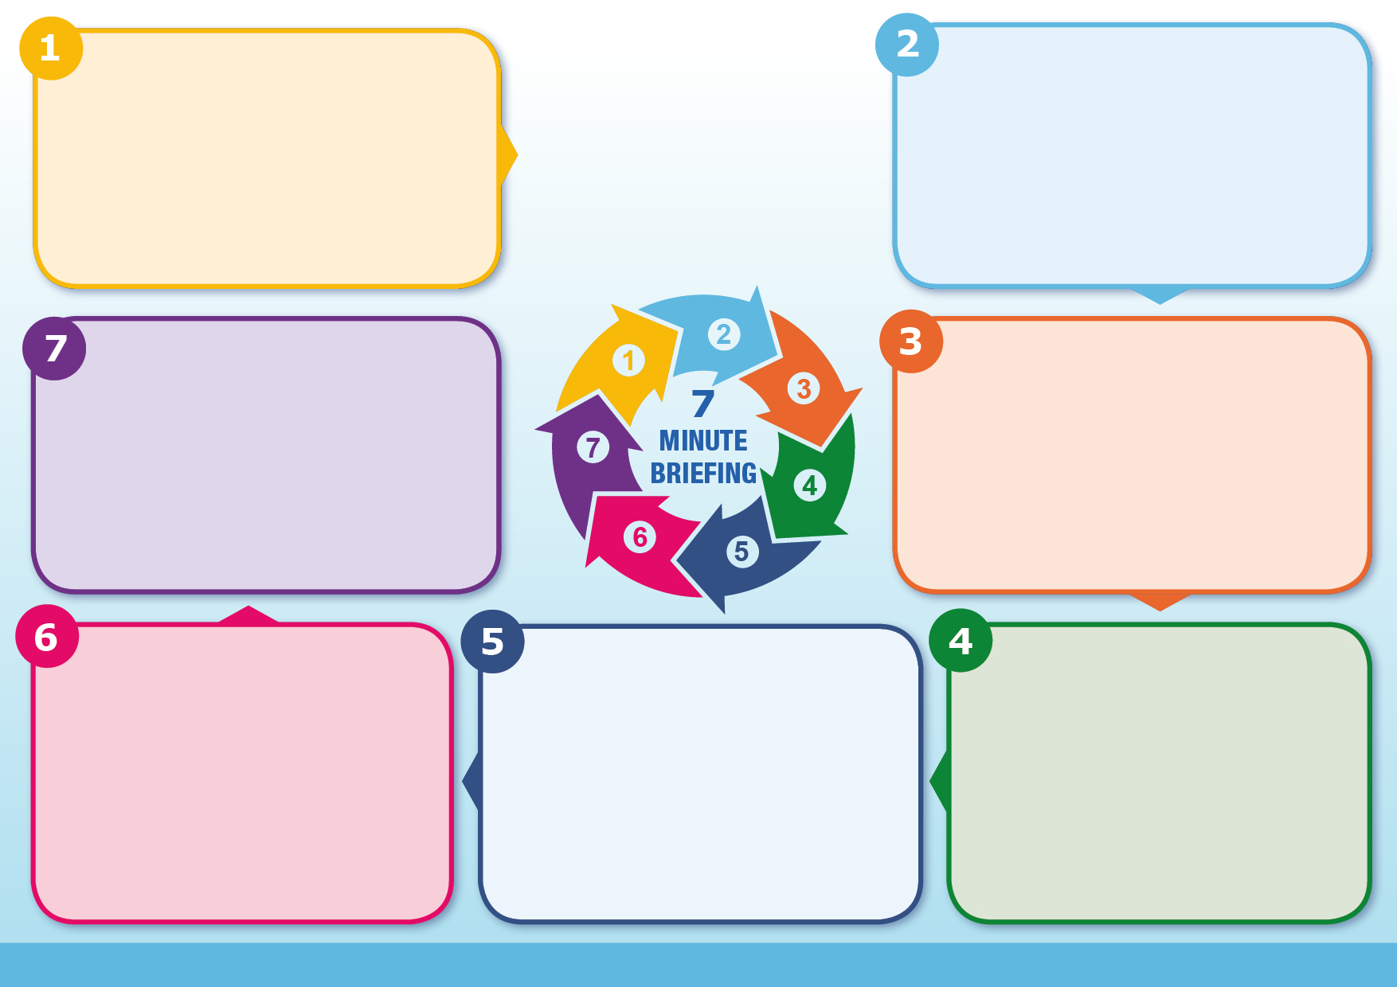
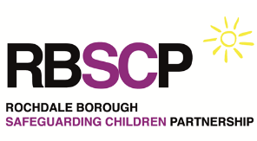
It is a Joint Targeted Area Inspection for evaluating services of vulnerable children and young people. The services inspected are always statutory safeguarding partners which are the local authority, police and NHS ICB.
Our named Designated Safeguarding Partners are:
Sharon Hubber. Director of Children’s Services.
Alison Kelly. Associate Director Nursing, Quality and Safety.
Daniel Inglis. Chief Superintendent Rochdale Police.

Ofsted, Care Quality Commission and His Majesty’s Inspectorate of Constabulary and Fire & Rescue Services plus any other named framework inspectors will work together to identify how well agencies within an area identify, support & protect children and young people.

They will utilise data, information, audit, MA meetings and onsite inspections involving discussion / observation with Leadership, Management and Practitioners.
• Ensure your records are up to date.
• Understand how to demonstrate children’s needs are understood and supported appropriately.
• Know how practice = evidenced effectiveness for children’s outcomes.
• Understanding of key documents (see next page)
• Be confident in your practice and able to explain the why behind assessment, planning and decision making.
• Discuss your cases during safeguarding supervision.

How can I be ready?
It is important you follow your role specific training and provide examples of how you do this. It is important you keep accurate records and know key strategies, policy and process.
HOWEVER:
It is equally as important that you know how you are making a difference in a child’s experience. When supporting a child, how do you know that interventions have meant a more positive outcome? How do you know our work is making a difference?
Think – So what?
What arrangements will be evaluated?
• How practitioners identify the need & risks of a child.
• How practitioners respond to the need & risk.
• The quality of assessment, planning and decision making within need & risk in response to contacts & referrals via EHASH.
• Protecting and the care of children at risk of harm.
• Leadership and management of this work.
• How well the local safeguarding children’s partnership understands its effectiveness within need & risk.
How will a JTAI occur?
A JTAI inspection will look at 2 main areas.
1. How effectively the multi-agency partners work together within a shared vision of safeguarding.
2. How effective the local area vision and practice is in ensuring positive outcomes for children and young people.

It is important that safeguarding practitioners should understand and be able to explain how their practice and actions ensure positive outcomes for children.
What is the purpose of a JTAI?
JTAI Inspection Guidance
For queries or advice regarding JTAI requirements please contact the Rochdale Safeguarding Business Unit at RBSB.Admin@Rochdale.Gov.UK

Further guidance is available here: Joint inspections of local area services - GOV.UK (www.gov.uk)

What is a JTAI?
Support available

Website: Rochdale Safeguarding Partnership Board – AI video for JTAI: Click to open new window

Key Multi-agency documents for JTAI need & risk inspection. All available on Rochdale Safeguarding Partnership Board –

Title | Description
Multi-Agency Referral Form (MARF) | The referral form designed for multi-agency contacts which details information of a child in need of support.
Child Need & Response Framework (CNRF) | Multi-agency documentation to support the assessment and identification of a child’s level of need and response within agreed safeguarding models.
Escalation Policy | The multi-agency process for professional challenge to support the positive outcomes for children.
EHASH Handbook | Multi-agency handbook which describes the agreed EHASH system.
Neglect Strategy & Toolkit | Multi-agency agreed strategy which focuses on Early Help. The new toolkit to support the early identification of child neglect.
Early Help Assessment & Framework | Multi-agency documents describing the local Early Help model.
Step up / Step down protocol | Protocol to support safeguarding models of EHASH and Early Help.
RBSCP Strategic Priorities | The Multi-agency agreed activity to support safeguarding assurance in the Rochdale borough.

