
- Background:
Parental mental ill-health is not an automatic indicator of a child safeguarding concern, but all assessments must include an assessment of the impact on children.
Local learning demonstrates that:
• Focus is often on the mental health needs of the parent and not the impact of their behaviour on the child.
• The support needs of children acting as carers for their parents with mental ill health is sometimes not recognised by professionals.
• Professionals sometimes do not consider the potential impact on a child when withdrawing mental health support for parents.
•professionals can be overly optimistic when evaluating the impact of parental mental illness on a child and the likelihood of the parent to sustain change.

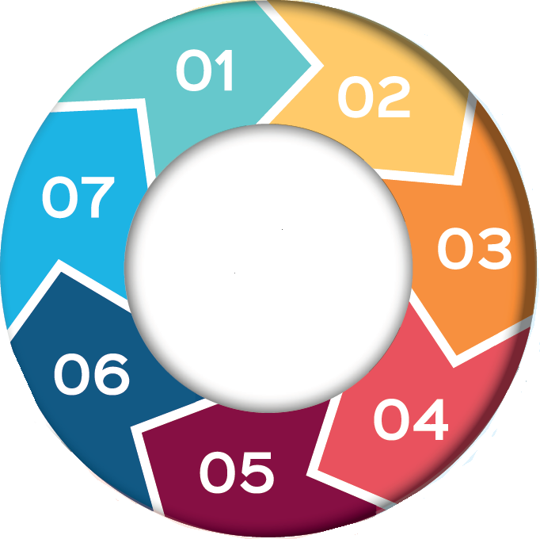

5. What can I do?
- Assess risks, vulnerabilities, stressors and protective factors using the PCFT Think Family Model
- Communicate with other PCFT services working with the family
- Liaise with your Health Service partners: Midwife; Health Visitor; School Nurse; GP
- Work in partnership with the family
- Inter-agency communication and information sharing
- Know how to access the threshold of need guidance for your Local Authority via the Safeguarding Partnership website (7. Resources)
- If concerns are at an early stage, consider an Early Help referral
- If you are concerned that a child has suffered harm or is likely to suffer significant harm, make a safeguarding referral to the Local Authority
6. Ongoing Safeguarding Actions
Invite CSC to attend-
- CPA planning and review,
- Discharge planning
Ensure that you are invited to:
- Early Help meetings
- Strategy meeting,
- Child Protection Conferences, Core Groups,
- Professionals' meetings
Inform partner agencies prior to case closure
7.Resources

- Safeguarding :: Pennine Care Extranet
- Children of Parents with Mental Health Difficulties
- Information Sharing 7 minute briefing podcast.
- Rochdale Safeguarding Partnership –
- OSCP | Welcome
- Bury Safeguarding Partnership - Bury Safeguarding Partnership
- Stockport Safeguarding Children Partnership (SSCP) - Stockport Council
- Home - Tameside Safeguarding Children Partnership
- How to make a safeguarding referral :: Pennine Care Extranet

Parental Mental Health
&
Parenting Capacity

4. Impact on children
- Anxiety, stress, low mood
- Carer role for parent or siblings
- Disrupted education
- Missed health appointments
- Stigma and shame
- Isolation
- Behaviour – withdrawal/acting out
- Abuse and neglect

Children should never be considered a protective factor for parents who feel suicidal or have mental health issues

Children should not be considered a protective factor for parents who feel suicidal or have mental health issues

3. Factors that may impact parenting capacity and be a cause for concern
- History of mental health with an impact on functioning
- Maladaptive coping strategies
- Severe eating disorders
- Problematic use of drugs, alcohol or medication
- Self-harming and suicidal behaviour
- Lack of insight into illness and impact on child
- Non-compliance with treatment/support
- Previous admission under MHA
- Previous referrals to Children’s Social Care for other children
- Mental health problems combined with:
- Domestic abuse/relationship difficulties
- Social isolation
- criminal offending

2. Parental Mental Health
Parents are: Biological and non-biological parents, Carers including grandparents, Pregnant women and their partners and any adult who has regular responsibility for the care of a child.
Mental health exists on a continuum from good mental health through to severe mental illness.

