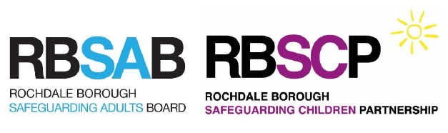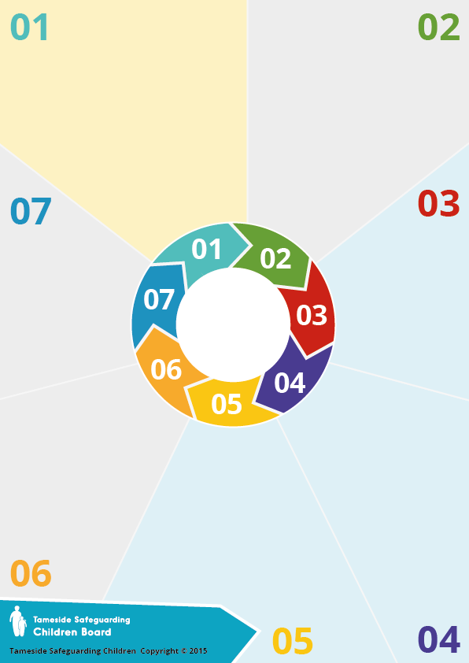

* Am I aware of the Greater Manchester Bruising Protocol?
* Do I understand how to use this protocol in practice?
* Am I aware of the escalation policy?
* Do I understand how to use this protocol in practice and effectively escalate?
* Before closing cases, am I clearly evidencing the rationale for this?
* Am I appropriately responding to referrals from members of the community, including family members?
* The Partnership should seek assurance with regard to responses to safeguarding concerns from members of the community connected to families. Responses should always recognise the unique position of members of the community and should consistently be recorded, followed up and acted on appropriately.
* Across the partnership, agencies should provide assurance that effective dissemination and implementation of the multi-agency Escalation Policy has been achieved. This should include the making and receiving of challenge including the recognition and consideration of perceived power imbalance
* The design of case closure summaries across the partnership to ensure the rationale for decision making is clear and changes in threshold application are explicit. The case closure summary should include an analysis of historical and ongoing risk factors
* Across the partnership, this review should be used to support a refocus on physical abuse.

**Recommendations:**

**Learning Points for Professionals:**

The published learning brief provides a summary of learning points, aimed to serve as reflection points for professionals across the Partnership who may face these types of dilemmas on a daily basis.

* The children were subject to physical abuse whilst professionals were significantly involved with the family
* The case highlighted the impact some unresolved professional disagreements may have on partnership working
* Professionals were distracted by listening to adults rather than the children
* Professionals were concerned that mother was vulnerable to further abusive relationships, with the potential that her children were at risk of serious harm – as happened in this case
* Assessments did not draw upon family history or encourage mother’s ability to safely parent
* Too much trust was placed in mother to manage a very challenging partner – without any

acknowledgement of the risk he posed

After a series of events, an ambulance attended the family home following reports of a child vomiting and struggling to breathe. Significant bruising was found on one child along with injuries indicative of abusive head trauma. Bruising was also found on the other child, indicative of non-accidental injury.

**Process and Background:**

Working Together 2015 set out requirements for Local Safeguarding Children’s Boards to commission Serious Case Reviews of cases that meet set criteria. This review was commissioned in 2017.

The case involved children who had been subject to a Child Protection Plan for neglect which was stepped down to a Child in Need plan. After the child in need plan ceased, the children were known to health services only.

Mother developed a new relationship with a man who had a criminal history. They were not honest with professionals about their relationship when a number of safeguarding referrals were instigated.

**What does this mean for me?**

**Emerging Issues from the Review:**

**Questions?**

How can I learn more about this Serious Case Review?

The extended learning brief for Child X1/X2 is available on the RBSCP website (www.rbscp.org)

Learning is also incorporated into the multi-agency safeguarding training programme.

**More information at**

[**www.rbscp.org**](http://www.rbscp.org)

**Child X1/X2**

**Serious Case**

**Review**