

**Rochdale Borough Safeguarding Children Partnership**

***Multi-Agency Response to Need***

**Guidance for families, professionals and communities**

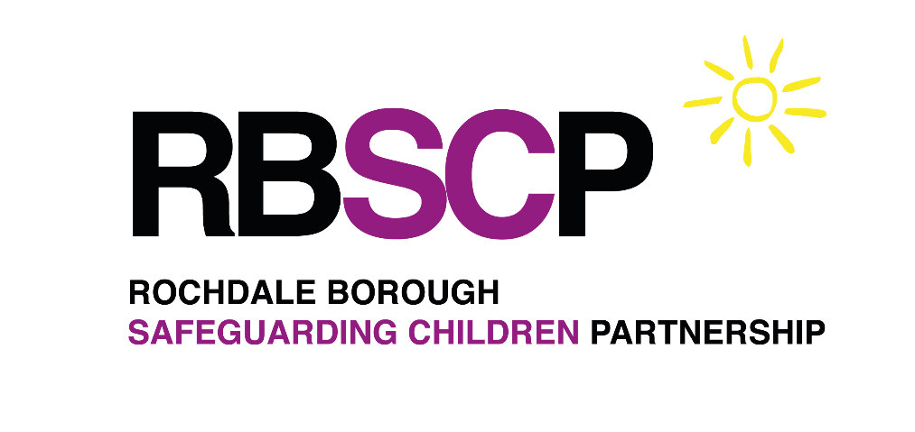

**Welcome to Rochdale’s Multi-Agency Response to Need Framework.**

**The Rochdale Multi-Agency Response to Need Guidance supports partner agencies across Rochdale to assess and identify a child’s level of need and how to access the right level of support at the right time.**

Rochdale Multi-Agency Response to Need Guidance underpins our vision to provide support for children, young people and families at the earliest opportunity to promote the wellbeing and safety of children and young people. It aims to offer clear guidance and to promote a shared awareness of how we meet children, young people and family’s needs in Rochdale and step in and step out to help and protect children, young people and their parents/families to meet their needs and achieve best outcomes.

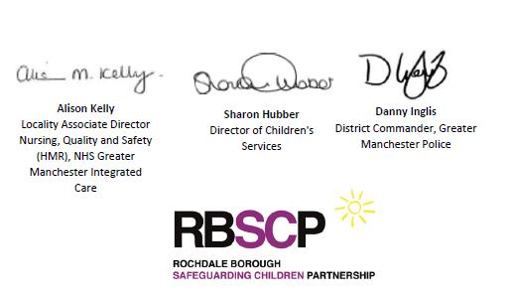

**The Rochdale Children Safeguarding Partnership values are:**

* **Safeguarding is everyone’s responsibility**: for

Services to be effective each citizen, practitioner and organisations should play their part.

* **A Whole Family Approach to supporting families.** For services to be effective and create long lasting, positive change we need to support the whole family, regardless of the level of need.

The Designated Safeguarding Partners would like to acknowledge all those who participated in and contributed to the development and implementation of the **Multi-Agency Response to Need Guidance.**

**Introduction**

The Rochdale Multi-Agency Response to Need Guidance has been developed to provide help and guidance to anyone who is concerned about a child. This includes families, professionals in any sector and the wider community. It should be used to support them to understand the type of support that is available to help and protect families, and how and where to access this support. Where ever possible we want to be able to support families to find their own solutions, and to clearly identify when families might need more support.

Working Together to Safeguard Children legislation requires the partnership to publish clearly defined guidance in relation to ‘thresholds of need’. You can find details of Working Together 2023 via the link on page 12.

**This guidance is designed to help practitioners/professionals to:**

* Share a common understanding of children’s help and protection needs
* Understand the child in the context of their family, wider community and experiences
* Recognise the role in supporting families to identify their strengths and needs.

**The guidance aims to support all to understand how and where to access the right help and support for children, young people and their families at the right time. As well as recognising that all services may step in and step out when required to do so to help and protect our children and families.**

All children and young people have the right to be protected from harm and to have the opportunity to achieve their full potential. To achieve this, the guidance clearly defines the importance of strong multi-agency working to help children and young people reach their potential. Therefore, all services and practitioners working in Rochdale Borough should ensure that their policies and practices reflect the requirements set out in this guidance document.

**How we work with Families across Rochdale Borough**

In the Rochdale, we are committed to providing the right help, at the right time by the right person across our agencies when it comes to working with children, young people and families. The questions below underpin the conversations we need to have with families when we believe that children, young people are not receiving the care and support they need, or there are concerns of harm:

• What are the strengths?

• What are the concerns?

• What steps need to be taken?

Using this approach as the basis of a conversation about a family’s needs can help:

• Understand present and past concerns

• Recognise existing strengths and safety

• Be clear about what needs to happen next

• Remain curious about what you’re hearing and seeing

The use of a strengths-based approach can often lead to families overcoming difficulties and challenges through adapting or tailoring universal or targeted services, without the need for statutory child protection services.

We understand that sometimes families find it difficult to share their story and accept help from professionals, we encourage you to consider what can be done differently to form trusting relationships and enable engagement, as well as considering if statutory intervention is necessary. Adopting an approach which is trauma informed, using non-victim blaming language and being professionally curious as to what you are hearing and observing is key to building this relationship.

**If you have concerns that a child is suffering or is likely to suffer significant harm then a referral to Early Help and Safeguarding Hub (EHASH) should be made via the Children’s Portal ‘Safeguarding Concern page’ and Telephone: 0300 303 0440 (0300 303 8875 Out of Office hours).**

**If positive change has not been achieved or sustained via Universal and/or Targeted Early Help services with a referral into EHASH would be appropriate, via the Children’s Portal ‘Worried about a child’ page.**

**Reflective questions for practitioners to evaluate concerns when considering if a family needs help or protection:**

* What have you seen or heard that worries you?
* What are you most worried about?
* What do you think will happen if nothing changes?
* Are things getting worse?
* Have you asked the child what they are worried about and captured this?
* Is anybody else worried about the child and have you spoken to them?
* What impact is all of this having on the child?
* Does the child or the family receive support from anywhere else? If they do, is it making things better?
* Does the child or family do anything already that makes things even a little bit better?
* What do you think needs to happen to make things better for this family?
* What services or agencies are needed to support this family?
* What support and interventions has already been offered and the difference it has made?

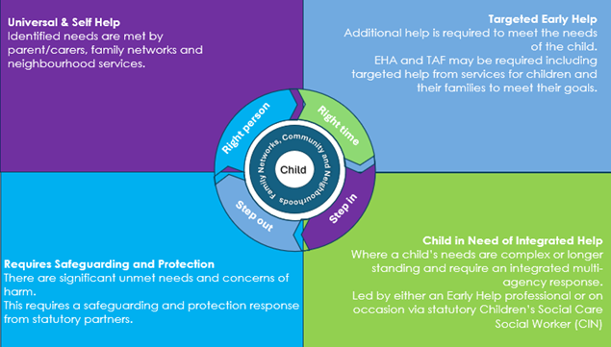  
Multi-Agency Response to Need: Diagram

UNIVERSAL & SELF-HELP

Most children and young people reach their full potential through the care of their families and communities. **Universal Services are provided to all children, young people and their families through community networks such as schools, primary healthcare, and leisure services, voluntary and universal groups.** Some examples

* Attends GP appointment when required.
* Good school attendance and attainment
* Attends and makes use of leisure activities in their community
* Is able to self-refer for help via voluntary and universal services when required
* Carers who meet their physical and emotional needs and protect them from danger and harm

**Needs can be met by Universal services**

All children and young people access universal services, including health, education, leisure, and youth services. Most children, young people and their families only need Universal services to meet their needs within their local community and reach their full potential. A wide range of universal services are available to all children, young people, and their families and many of which you can self-refer

Examples of services offering universal services are below:

* GPs
* Schools
* Family hubs
* Health visitors, midwives and school nurses
* Housing Services
* Youth services
* Debt and welfare rights
* Emergency Services
* Charities and Voluntary Groups

We recognise that all practitioners, regardless of the agency that they are from, have a role to play in safeguarding children and young people form harm and promoting their welfare. **The professionals working in Universal Services are best placed to identify children, young people or their families who might not thrive without getting extra help.** Support for children and young people must promote welfare, safeguard the child and, where possible, prevent harm before the child’s needs become more complex. Rochdale Borough believes that the best way to support a child is through early intervention, as soon as it is identified that a family needs support.

TARGETED EARLY HELP

**Early Help provides support when need is identified at any point in a child’s life. It is not service specific to one organisation, but rather a collaborative approach across all agencies and partners to work with children, young people and families to prevent the need for statutory intervention and meet need at the earliest opportunity.**

In Rochdale every person working with or engaging with children, young people and families, regardless of organisation, status or position, has a responsibility to support the delivery of Early Help and support the family to access appropriate services to enable environments in which children, young people and their families can thrive.

Rochdale Borough has a comprehensive offer through Family Hubs that provide support for parents, carers, children and young people. Family hubs provide a single access point to integrated family support services for early help with social, emotional, physical and financial needs. Each family hub is bespoke to its local community while incorporating three key delivery principles: access, connection and relationships.

**Any individual agency/practitioner can initiate an Early Help Assessment and act as a lead professional to support the child and family to identify need, capture the views and develop the support plan. You can find more information on LP role on page 10.**

Our Family Hubs include Early Help and Early Years practitioners, who aim to work with families at an early stage before their needs increase. They will offer support and work with families to understand their needs through an Early Help Assessment and work together to develop a plan to make sure that parents can support their children and young people**. Families should always be encouraged to access support from our Family Hubs and Neighbourhood Early Help Teams as soon as problems emerge.** Early Help workers in the Family Hubs will also help and support partners in relation to providing Early Help support to families they are working with. You can refer families for help via Family Hubs through the Children’s Portal, ‘Early Help Neighbourhood’ page.

Other services that can that step in to provide Targeted Early Help include;

* Youth workers
* Nurseries, Schools and Colleges/Sixth Form
* School nurses
* Health Visitors
* Family Support Workers
* SEND services

CHILDREN IN NEED OF INTERGRATED HELP

**Child in Need of Integrated Help**

These are children and young people whose needs are more complex, based on a range of needs or significance of the needs. They are at risk of social or educational exclusion. Their health, welfare, social or educational development is being impaired and life chances will be impaired without the provision of additional help. Those are children, young people and families who also require support from Rochdale Council Children Services either via a timely response from the Early Help and Engagement Team or via s.17 Children’s Social Care. These children and young people require a coordinated multi-agency support plan to meet their need.

In addition, all disabled children and young people are ‘Children in Need’ and have a right to an assessment, this will not necessarily be a full Children’s Social Care assessment.

This may include, children and young people who are unlikely to reach or maintain a satisfactory level of mental or physical health or development, or their health and development will be significantly impaired, without the provision of services

**There are a range of services that can step in to help children, young people and their families in need of integrated multi-agency help including;**

* Family Safeguarding Children’s Social Care
* Early Help Engagement Team
* Complex Safeguarding
* Children with Disability Team
* Education and Healthcare Plan Team
* Emotional Based Non Attendance Team
* Family Group Conferencing
* No Wrong Door
* Specialist mental health support
* Domestic Abuse Services

**Children, young people and families will require a referral into Rochdale’s EHASH via the Children’s Portal ‘Worried about a child page’.** As in line with the guidance, ongoing help and support from Universal and Targeted Early Help Services will likely still be required for these children and young people.

REQUIRES SAFEGUARDING AND PROTECTION

Children and young people may require an immediate referral to the Early Help and Safeguarding Hub (EHASH) where there are concerns of harm. You can make a referral via EHASH Children’s Portal ‘Safeguarding Concern’ page and call 0300 303 0440. If a criminal offence occurs practitioners should also contact the police.

These are children, young people and families with increasingly complex needs, those children and young people who are at risk of or are suffering significant harm. The Children Act 1989 introduced the concept of significant harm as the threshold that justifies compulsory intervention in family life in the best interest of children and young people and gives local authorities a duty to make enquiries.

A social work led Child and Family assessment will be completed to better understand their needs on conjunction with partner agencies to ensure the child is protected from harm.

**Safeguarding and Protection could include:**

* Children require immediate protection from harm including physical, sexual, emotional harm and neglect
* Children with unexplained injuries, or where there is inconsistent explanation of the injury
* Children from families experiencing a crisis
* Where there are serious concerns regarding significant harm to an unborn baby
* Where there are criminal and/or sexual exploitation concerns in regards to children and young people
* Children who are remanded to Custody or who pose a risk of causing serious harm to others
* Children who allege abuse from family networks and/or professionals
* Vulnerable children who are unsupervised and with significant unmet needs
* Children who present as unaccompanied or without parents

**Services Include:**

* Children’s Social Care
* Police
* Health
* Education
* Supported by other partners and key stakeholders

**Lead Professional**

The role of the **Lead Professional** is to co-produce the Early Help assessment and the coordinate the multi-agency plan alongside the child/children and family and key partners to achieve identified outcomes. The Lead professional role can be undertaken by any agency/professional across Rochdale, when they have identified need for a child and their family.

It is important that all practitioners working with children, families and adults can assess strengths and needs and provide support as soon as a problem emerges. This may be at any point in a child’s life, from foundation through to teenage years. The Early Help Assessment supports the practitioner, child and their family to identify need, across health, education, relationships.

**The RBSCP Designated Safeguarding Partners following the implementation of Working Together 2023 have agreed that there will be no changes to the S17 lead practitioner role in Rochdale (Working Together 2023 page 45 paragraph 121) at this time. The partnership will review the decision following the evaluation of the pilots trailing stable homes built on love. Partners will be consulted should there be any suggested changes to this.**

* Early Help Assessments and Multi-agency plans should take into account the voice of the child and should be developed by working in partnership with the family.
* The Lead Professional role is vital in the identification of need and ensuring appropriate services step in and step out as and when required.
* The lead professional acts as a single point of contact for a child or young person and their family including the wider family network (where applicable) when a range of services are involved and an integrated response is required.
* The Lead Professional can seek help and support via other agencies including via Neighbourhood/Family Hubs to support the identification of support services that may work alongside the lead professional to meet child and family needs.

**Children’s Services Portal**

Safeguarding professionals who want to access early help support or make a safeguarding referral for children and young people must do so via the Children's Services Portal.

Professionals must use the link *[opens in a new window]* below to access Multi-agency referral forms for both Early Help - Neighbourhoods and the Early Help and Safeguarding Hub (EHASH).

[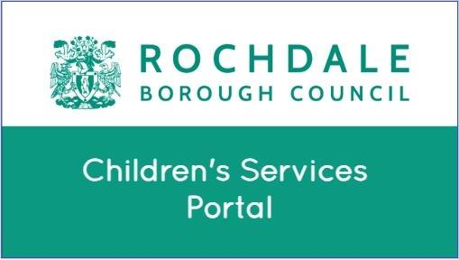](https://childrenslcsportal.rochdale.gov.uk/web/ll-openid-provider/web/oidc-auth?max_age=0&scope=openid+profile+email+phone&claims=%7B%7D&response_type=code&redirect_uri=https%3A%2F%2Fchildrenslcsportal.rochdale.gov.uk%2Fweb%2Foidc%2Fcallback&state=2E2OUzzVSQTbXVUaoLzzAHzvjhdBati5ffQkflHEqs0&nonce=3WQ_vyIQFKTncAQiiHYh6YVuRjFDxYKpk1Yv8oxHXZw&client_id=portal.RochdaleLCS.liquidlogic.co.uk&response_mode=query)

The RBSCP advises all professionals to watch the short guidance short video below, before accessing the Portal for the first time. *[Opens in a new window].*

[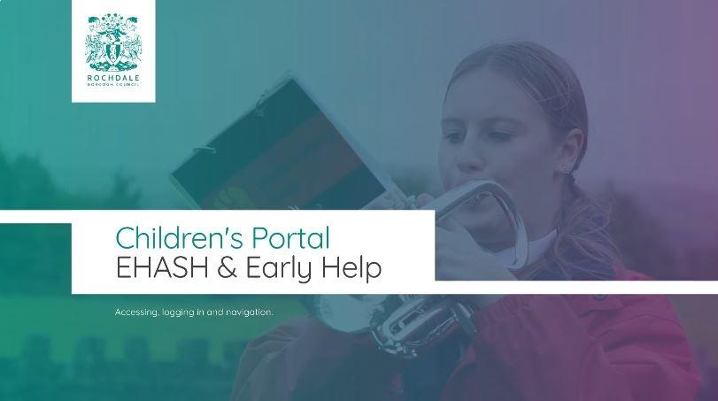](https://share.synthesia.io/42ef697c-7cbb-4d4a-bd99-aab6bd8a4baa)

Within the portal you will find detailed guidance regard and information with regards to Rochdale borough’s Early Help model, EHM user guide, Family Hubs, EHASH contact details and what to do in the case of safeguarding concerns.

**Information Sharing and Agreement**

**A 10 Step Guide to Sharing Information to Safeguard Children**

**Step 1:** Be clear about how data protection can help you share information to safeguard a child.

**Step 2:** Identify your objective for sharing information, and share the information you need to, in order to safeguard a child.

**Step 3:** Develop clear and secure policies and systems for sharing information.

**Step 4:** Be clear about transparency and individual rights.

**Step 5:** Assess the risks and share as needed.

**Step 6:** Enter into a data sharing agreement.

**Step 7:** Follow the data protection principles.

**Step 8:** Share information using the right lawful basis.

**Step 9:** Share information in an emergency.

**Step 10:** Read our data sharing code of practice

Taken from Information Commissioners Office

[A 10 step guide to sharing information to safeguard children | ICO](https://ico.org.uk/for-organisations/uk-gdpr-guidance-and-resources/data-sharing/a-10-step-guide-to-sharing-information-to-safeguard-children/)

It is important that we understand the rules for information sharing, but this is not always easy. Most of the time we share information about families with their agreement. However, there are occasions when we need to share information about a family without their agreement.

All practitioners have a responsibility to work alongside children, young people and their families to engage with them and build relationships that are honest and supportive, identifying strengths while being clear about the worries. We know from families that this approach works best, and they are more likely to engage with services in which they have confidence and trust. Refusal to engage with early support services or refusal to give agreement to share information are not in isolation reasons to escalate concerns.

**Consent MUST be sought, and means that the family is fully informed about the services they are being referred to, agree with the referral being made and understand what information practitioners are passing on and why.**

There are some exceptions when there is a need to protect children and young people. For example,

* If having a conversation with the family would place the child, or another child, at increased risk of suffering harm.
* You also don’t need consent if it might undermine the investigation of a serious crime. Anyone concerned about information sharing should also refer to [EHASH@rochdale.gov.uk](mailto:EHASH@rochdale.gov.uk)

**What if you have a disagreement about decisions and you are still worried about the child**

**Escalation Policy**

Effective partnership working is vital in order to ensure that outcomes for children and families are central to all assessment, planning and intervention. This includes the need to consider differing views and experiences which evidence the value of exchanging ideas and developing critical thinking in regards to how best to achieve improved outcomes.

There will be times when disagreements occurred and require informal and possible lead to formal escalation. In such circumstances you should first discuss the case with your line manager or the designated lead for safeguarding within your own organisation.

If, after this discussion, consensus cannot be reached, the issue should be progressed in line with the guidance set out in the RBSCP Escalations Policy. The Escalation Policy is embedded below.



**Whilst ongoing discussions are taking place between practitioners, should a child be in a situation where they are at immediate risk of harm you should contact the Police on 999. If you believe a situation to be urgent but there is no immediate danger, call EHASH on 0300 303 0440 in the first instance.**

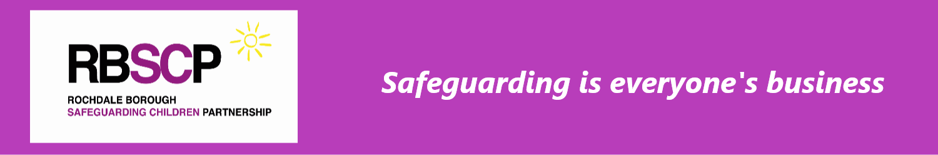

**Supporting Guidance**

This document is based on guidance as detailed in [Working Together to Safeguard Children 2023](https://assets.publishing.service.gov.uk/media/669e7501ab418ab055592a7b/Working_together_to_safeguard_children_2023.pdf)

A wealth of resources for practitioners is available at:

[Rochdale Safeguarding](https://rochdalesafeguarding.com/rbsp). This includes multi-agency procedures, training, specific information pages, guidance providing bite-size briefings on key.  
  
The latest version of the regional procedures manual can be found at [Greater Manchester Procedures (Tri-X Online)](https://greatermanchesterscp.trixonline.co.uk/)

A range of other useful documents can be found listed below:

**It is the responsibility of all partner agencies to ensure the Multi-Agency Response to Need Guidance is accessible and embedded in practice.**

|  |  |
| --- | --- |
| -Rochdale Borough Safeguarding Children Partnership Child Neglect Strategy 2022 - 2025 |  |
| -Neglect Toolkit |  |
| -LADO Guidance  -Child in Need Policy  -Step in / Step out  -Early Help |  |

