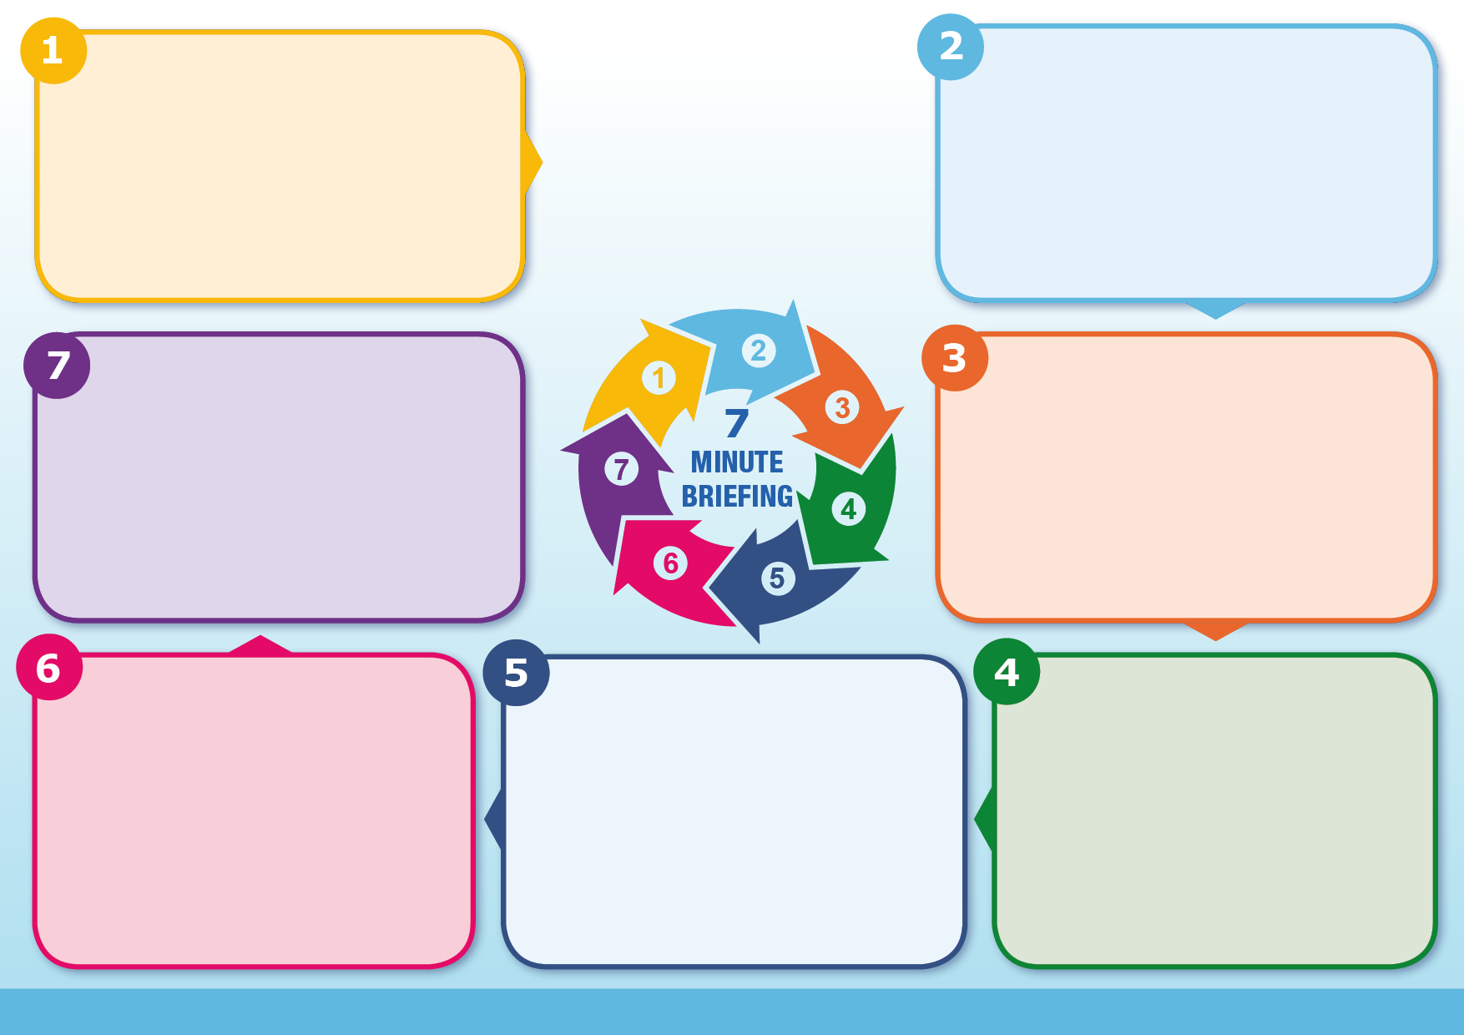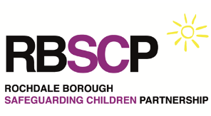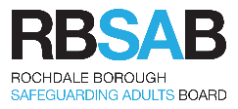

Remember that research has shown that only 7% of communication is verbal! Being observant is very important as children may say one thing but their body language & behaviour may signal something different.

Give sufficient time, be patient and insist that children’s’ voices are not only heard but also used to inform our practice.

**What to do?**

Do I understand what this child's life is like, what do they do each day? What do they feel about their lives, how would they want things to change?

Do we effectively capture the voice of the child and their lived experience in assessment, planning and records?

If I have concerns about my own personal safety, have I considered the level of risk for children in this household?

**Questions**

Observe interactions between children & parents/carers.? What is your hypothesis about their behaviour?

Encourage children to participate in meetings, including Child Protection Conferences. They can do this directly by attending or by putting something in writing, drawing a picture or asking someone to speak on their behalf.

**Information**

Even if children are too young to speak it is still essential to convey a sense of what life is like for them. Describe their presentation; how others interact with them and how they respond; comment on whether you consider they are functioning at a developmentally appropriate level

Include the views of other significant people in the child’s life who may have contributions to make about the child’s experiences, e.g. grandparents, aunts, uncles & neighbours.

**Information**

Children must be seen alone. They may not be able to talk openly about their experiences in presence of a parent/carer

Children may feel less inhibited about speaking if they are in a safe, neutral setting

Talk to children about their lives, their likes & dislikes, hopes & dreams, worries & fears. There are a variety of ways of gaining their views through techniques such as ‘Three Houses’.

Record what children say in direct quotes (e.g. ‘I feel sad/happy/worried when…).

**Information**

A legal duty exists to listen to the wishes & feelings

of all children, including children in care.

The UN Convention on the Rights of a Child states

that it’s a child’s right to be heard & taken into account

The Voice of the Child is part of Ofsted inspections

This is a phrase used to describe the real involvement of children and young people. It does not only refer to what children say directly, although it is essential this is heard,

but it refers to many other aspects of their presentation. It means seeing their experiences from their point of view and taking into account the child’s daily lived

experience. The phrase means more than simply seeking their views; is about enabling them to take as active a role as possible in decision making.

**What is the legal context?**

**What is “Voice of the Child”?**

**Voice of the Child**